**Auto Scaling Group Tasks**

1) Create one vpc in N.virginia region.

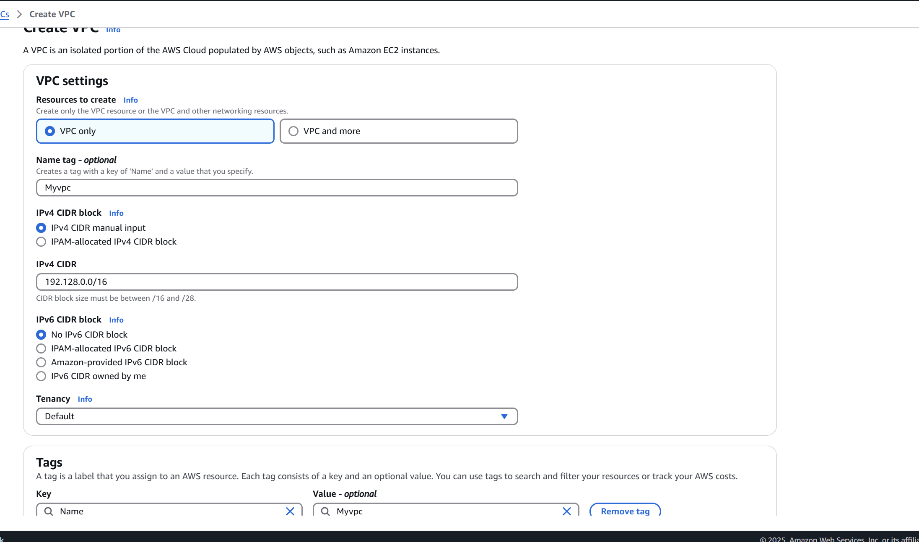

2) Create two subnets.

One Public subnet and one private subnet.

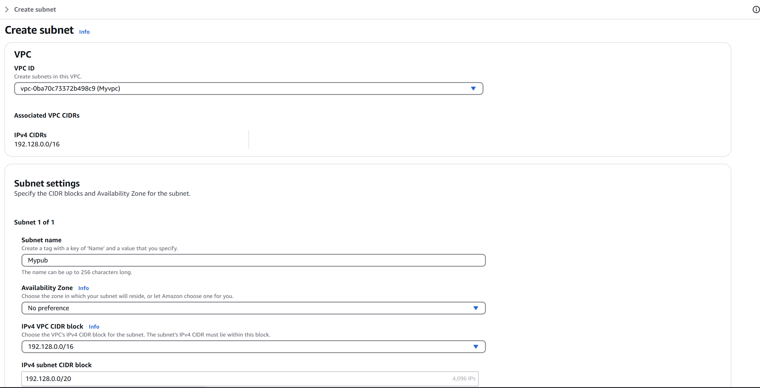

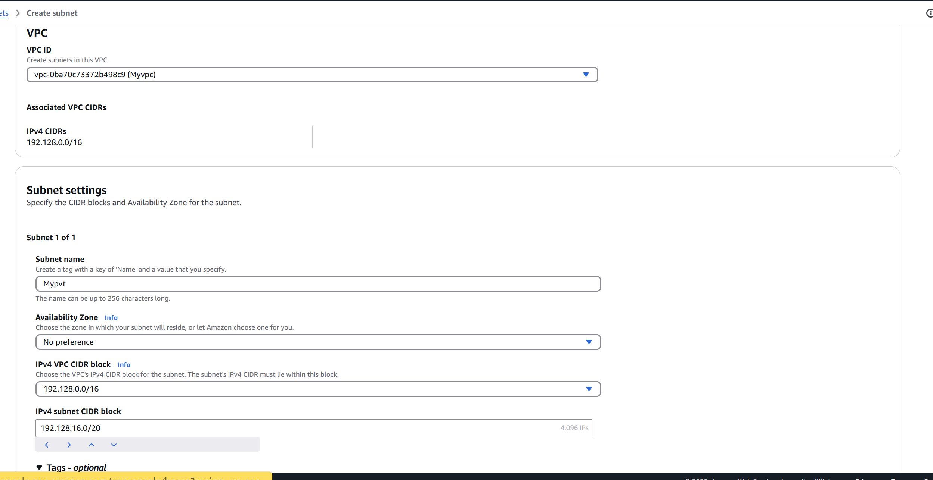

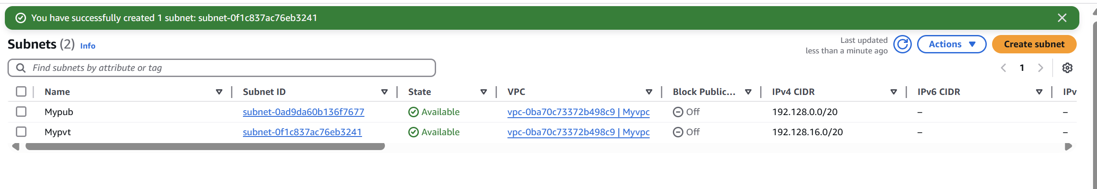

3) Provide the IGW to the vpc.

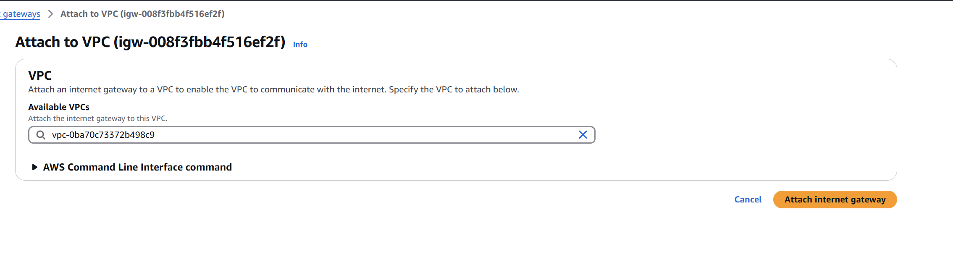

4) Create One public RT and one private RT.

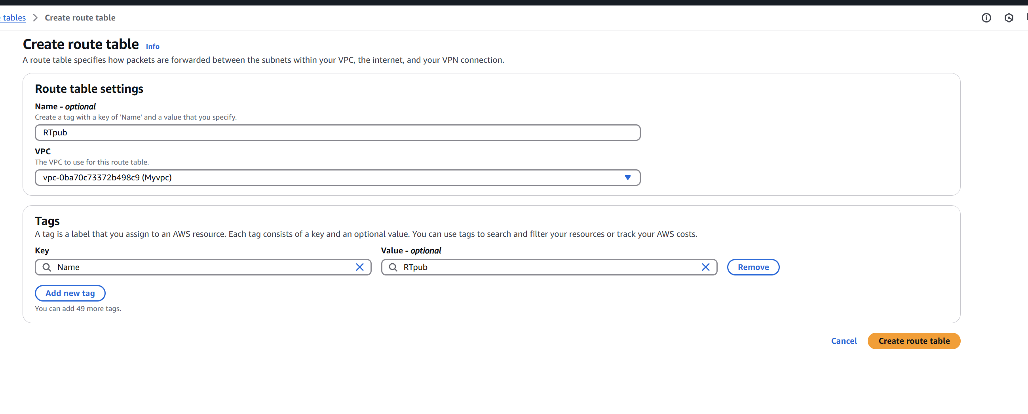

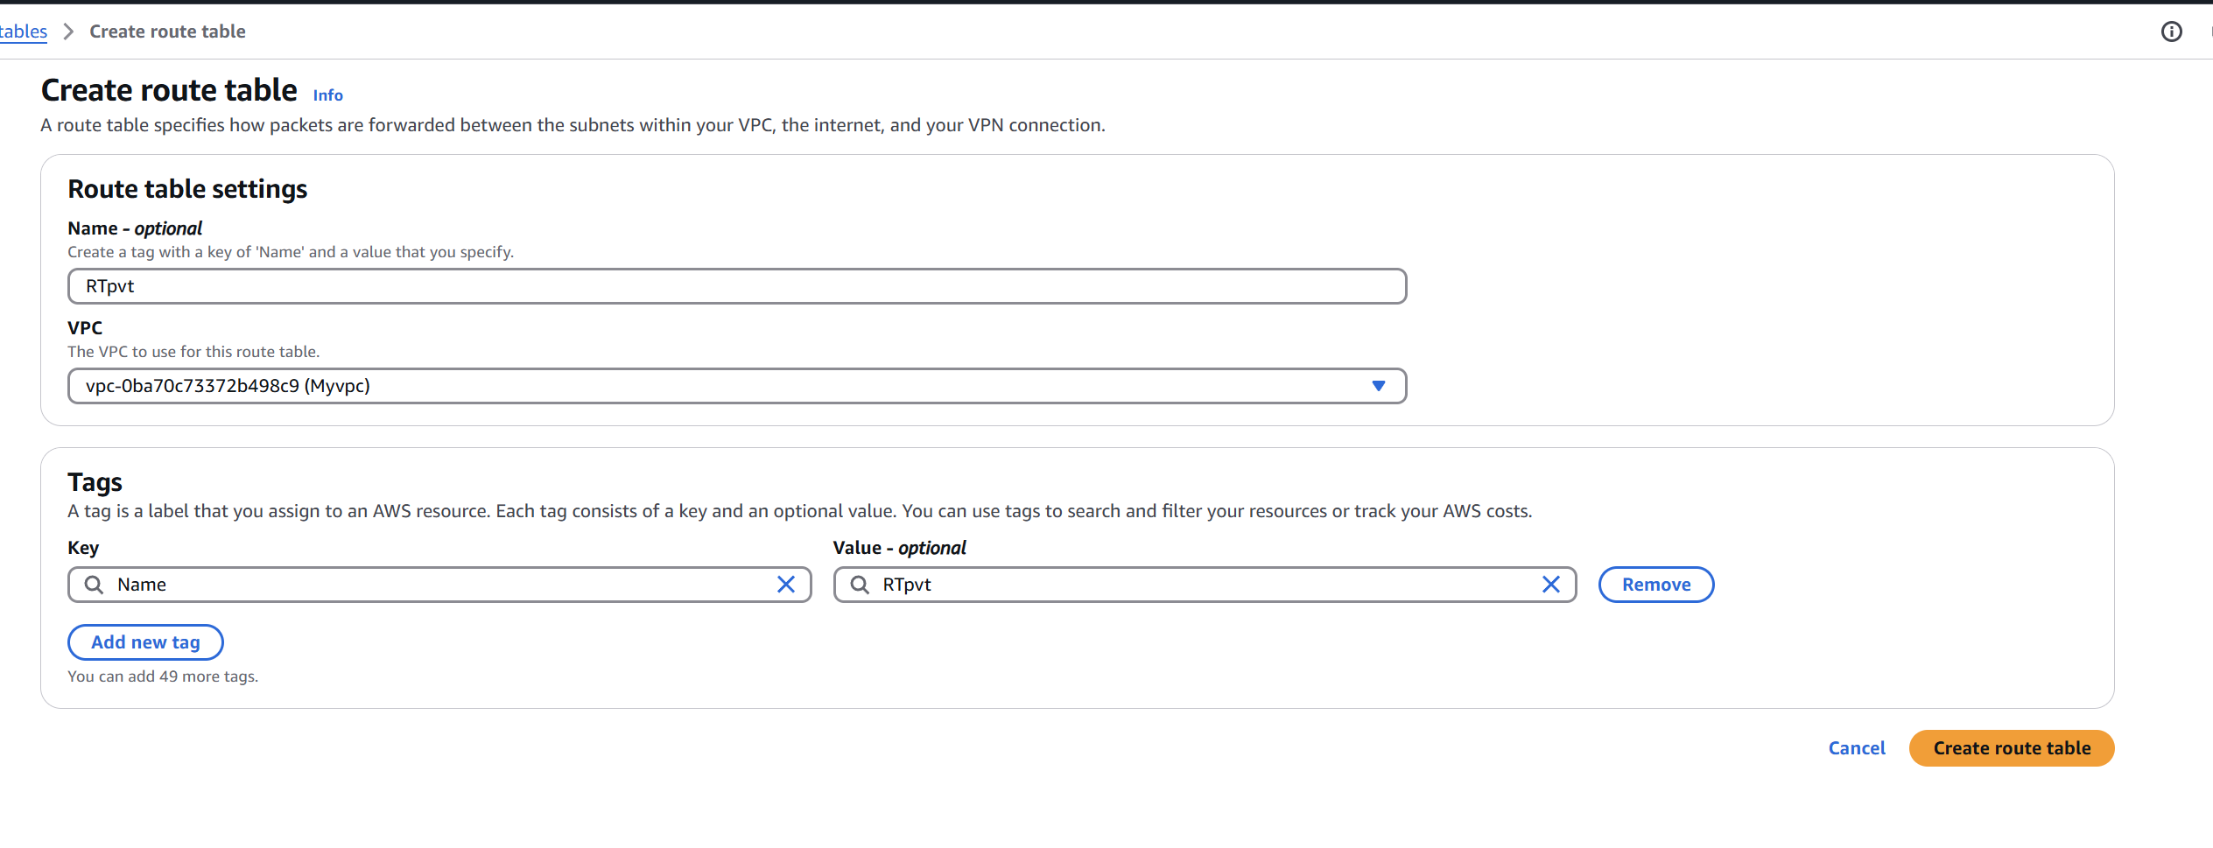

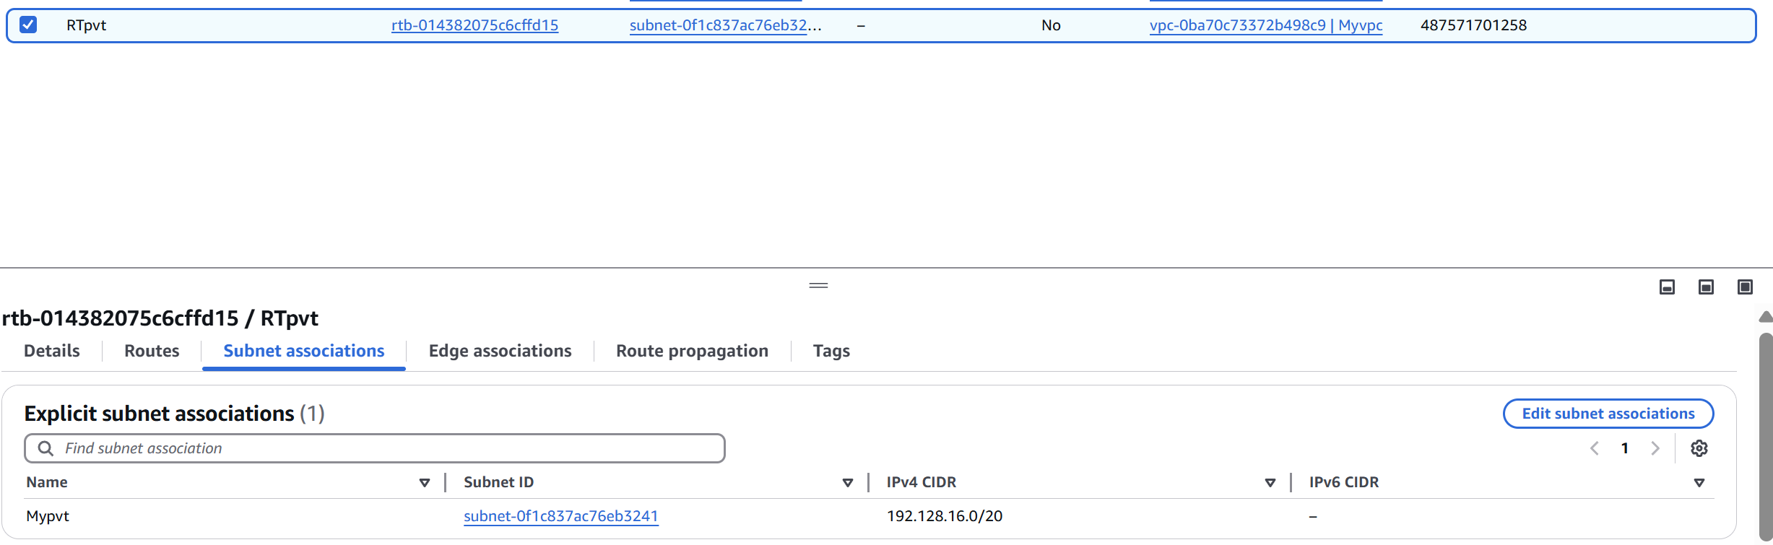

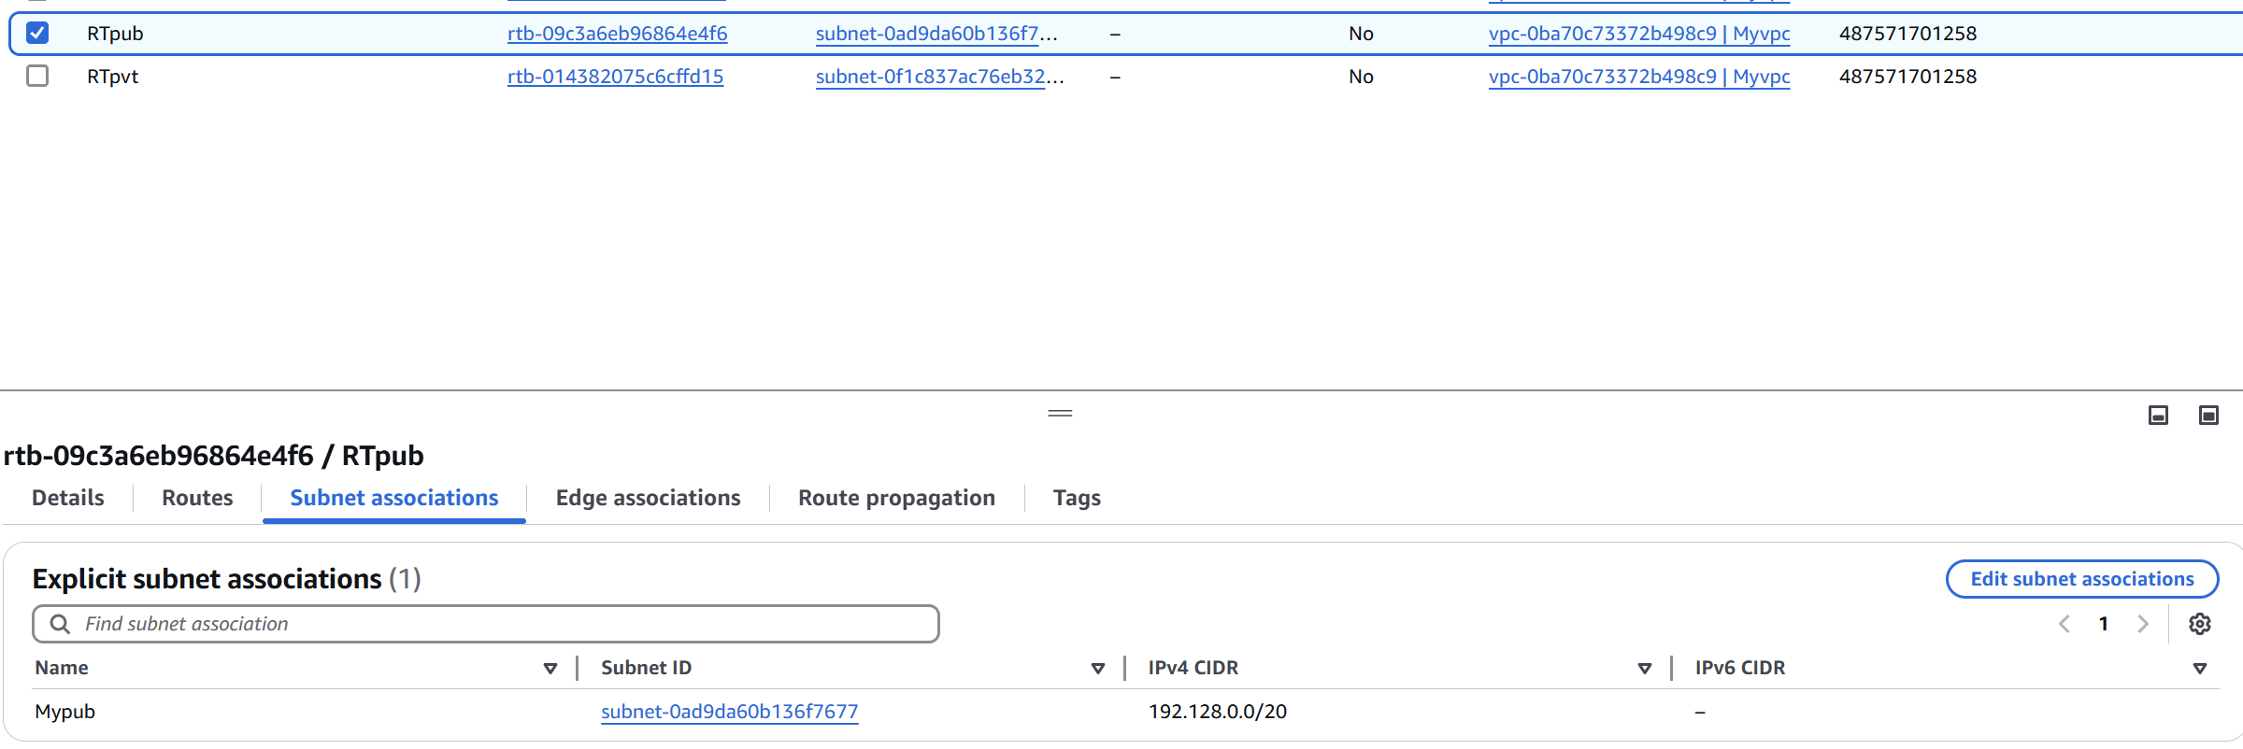

5) Deploy NAT gateway on public subnet and attach the NAT gatewat to private subnet.

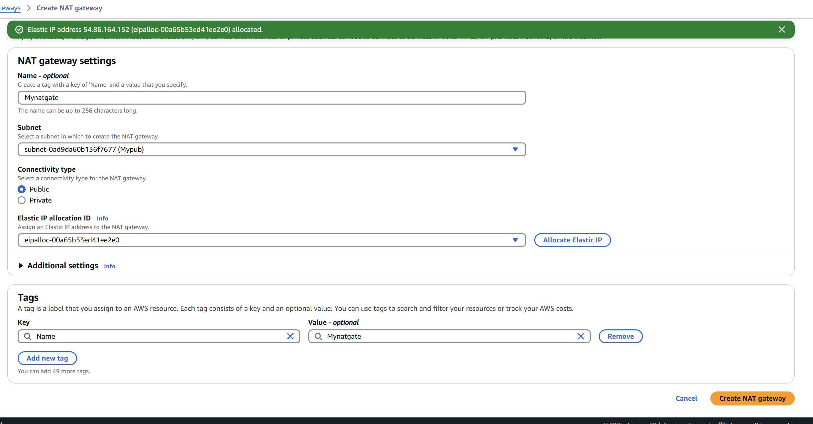

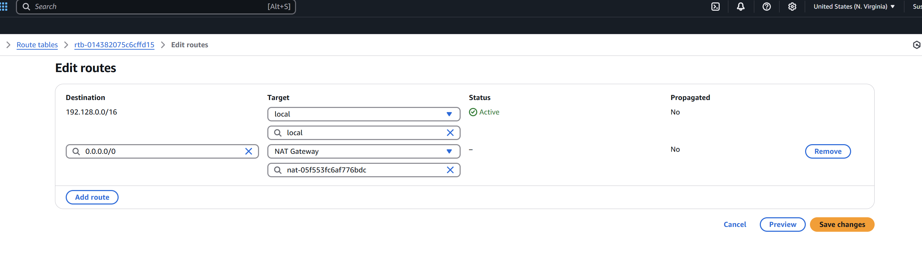

6) Create Two instances,one in public subnet and one in private subnet.

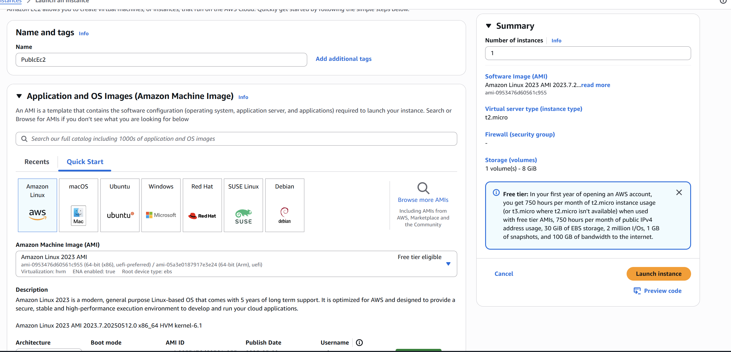

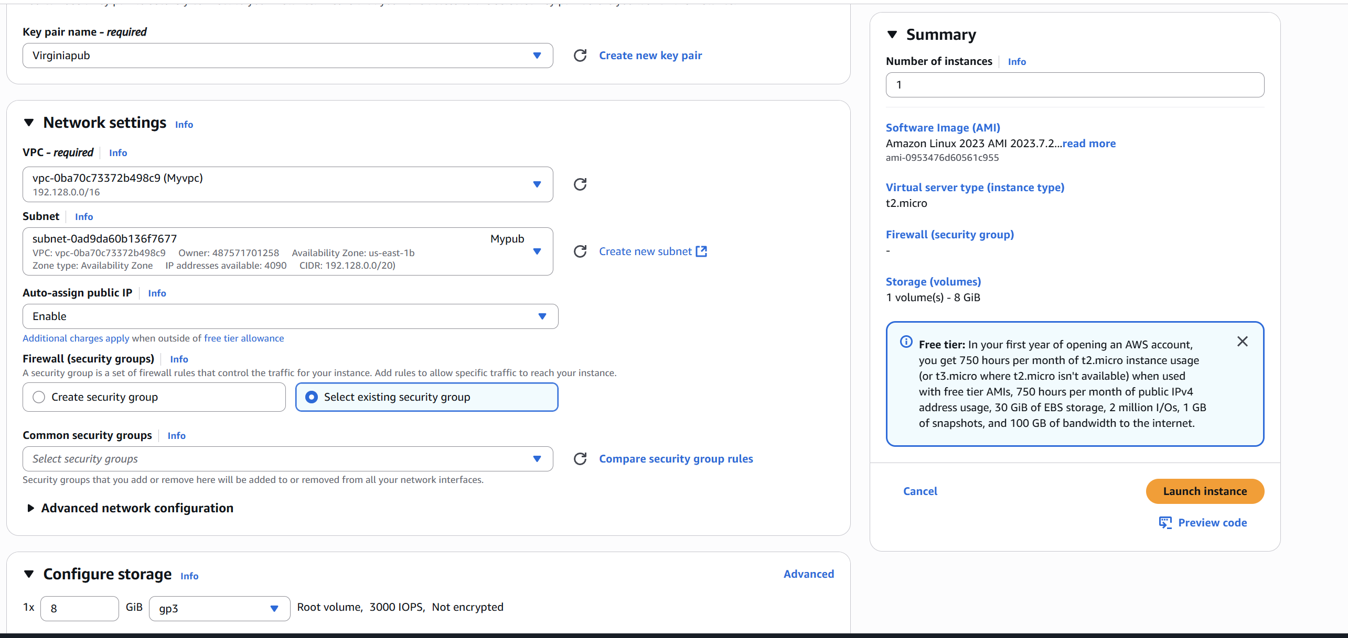

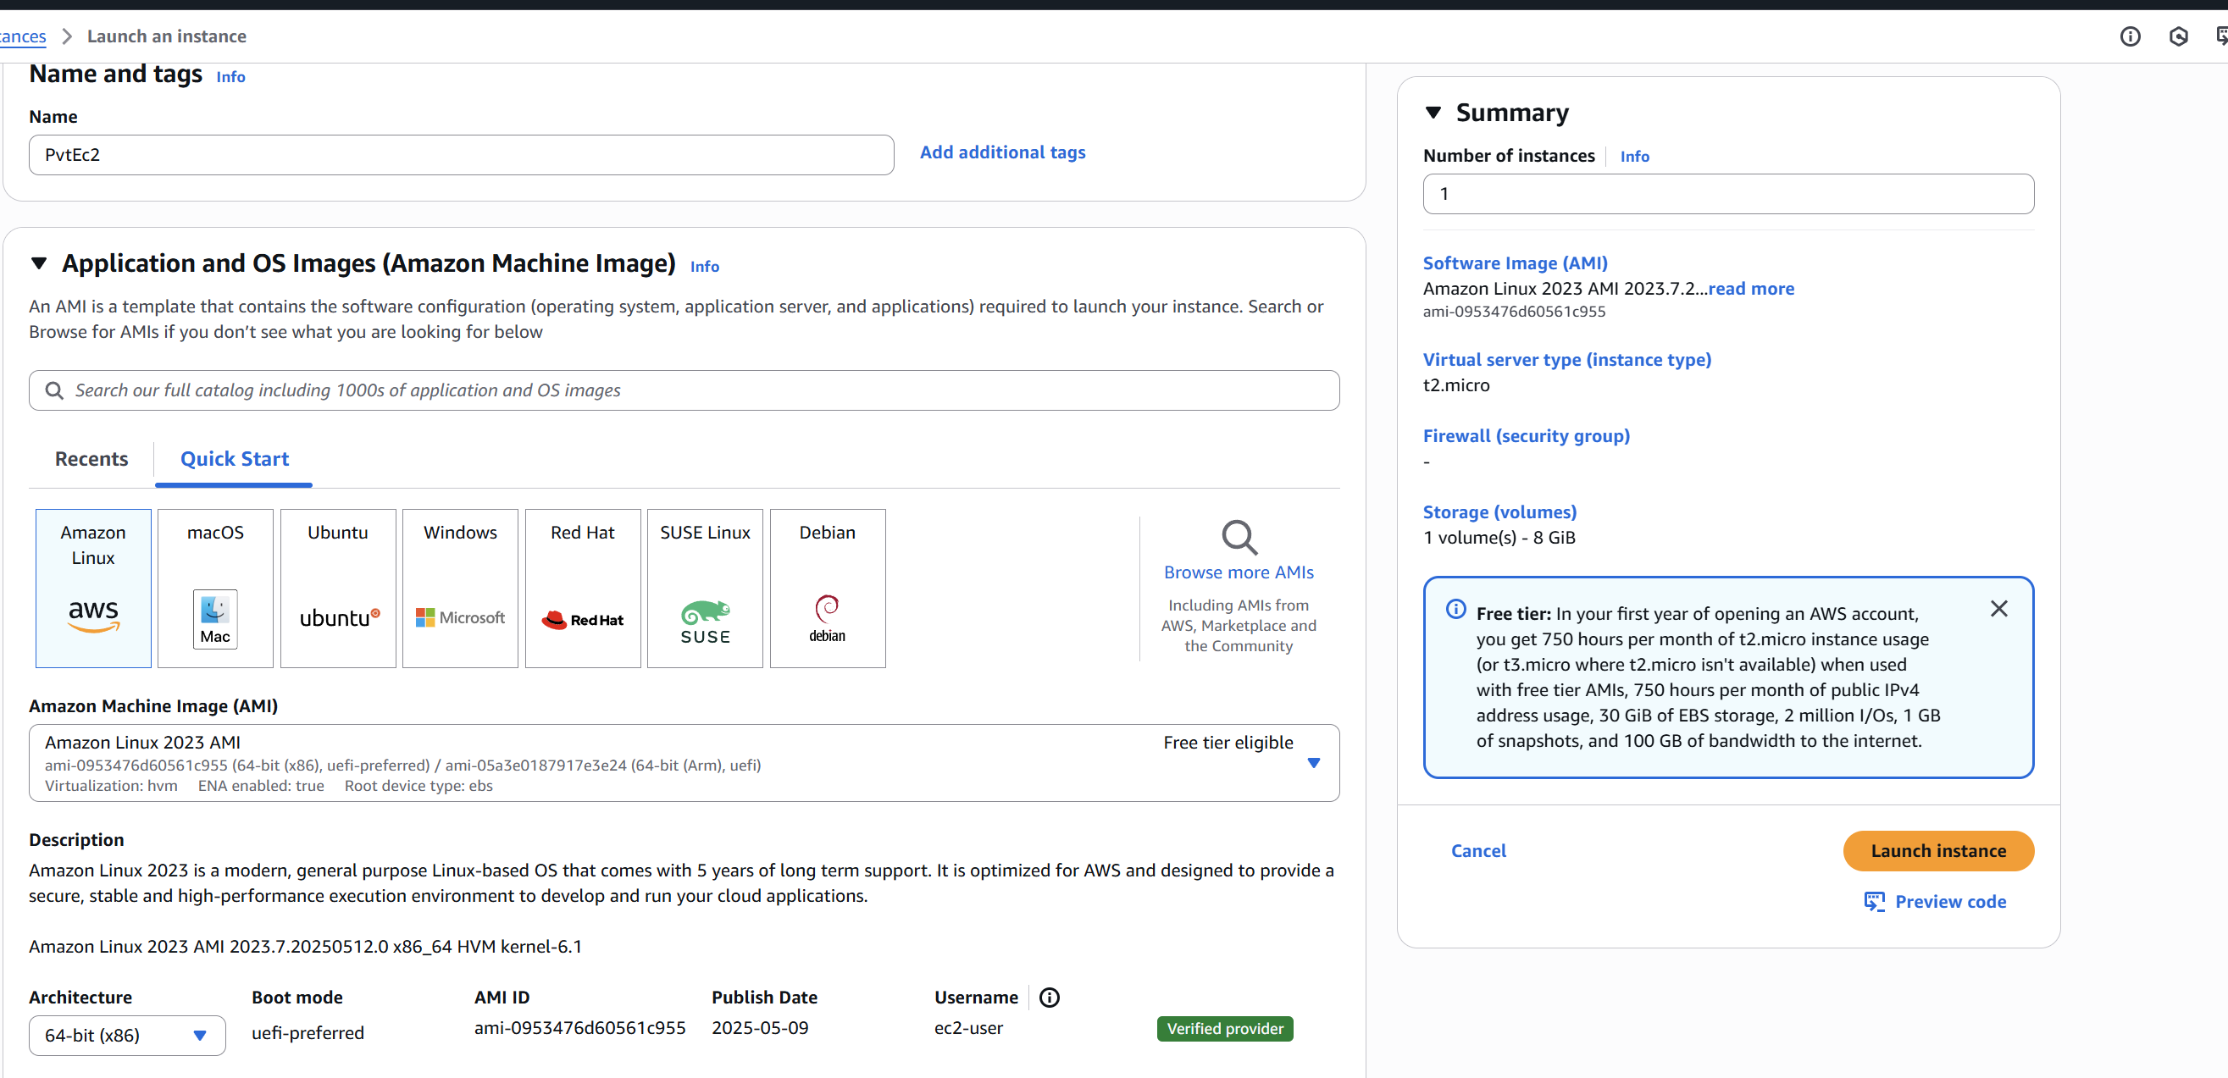

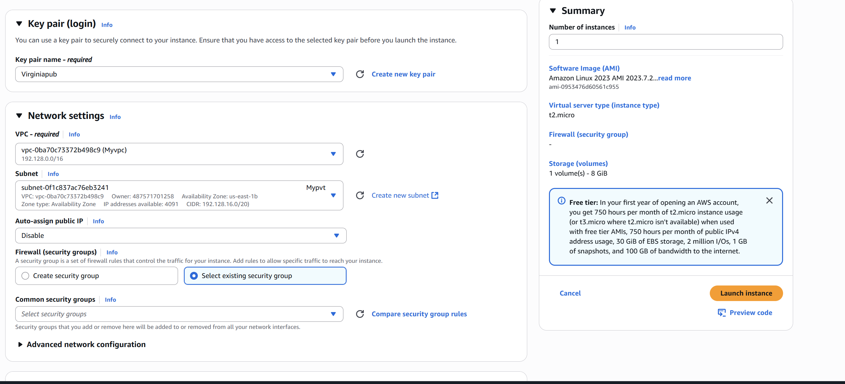

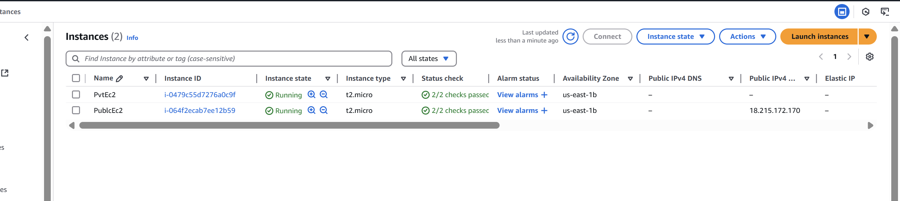

7) Deploy Apache server on both the ec2 instances with sample index.html file.

Using Public Ip Instance:

* SSH into each instance separately:

ssh -i your-key.pem ec2-user@<EC2-IP-ADDRESS>

* Install Apache (httpd)

sudo dnf install -y httpd # Amazon Linux 2023

# OR

sudo yum install -y httpd # Amazon Linux 2

* Start and Enable Apache

sudo systemctl start httpd

sudo systemctl enable httpd

* Add a Sample index.html File

Create a simple HTML file:

echo "<h1>Hello from $(hostname -f)</h1>" | sudo tee /var/www/html/index.html

* Allow HTTP (Port 80) in Security Group

Add rule:

**Type**: HTTP

**Port**: 80

**Source**: 0.0.0.0/0 (or restrict to your IP)

* Test in Browser

http://<EC2-1-PUBLIC-IP>

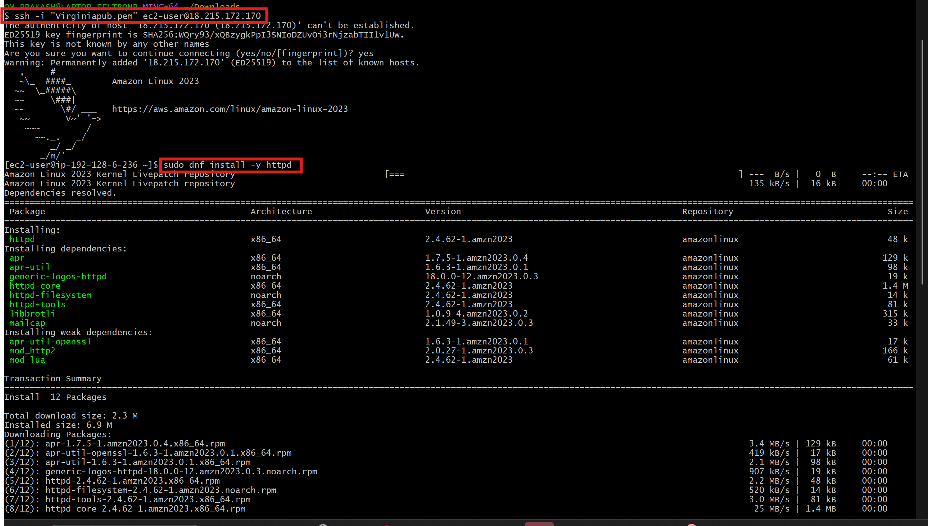

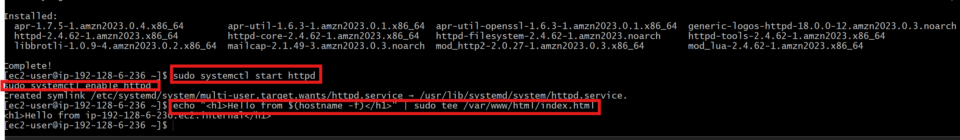

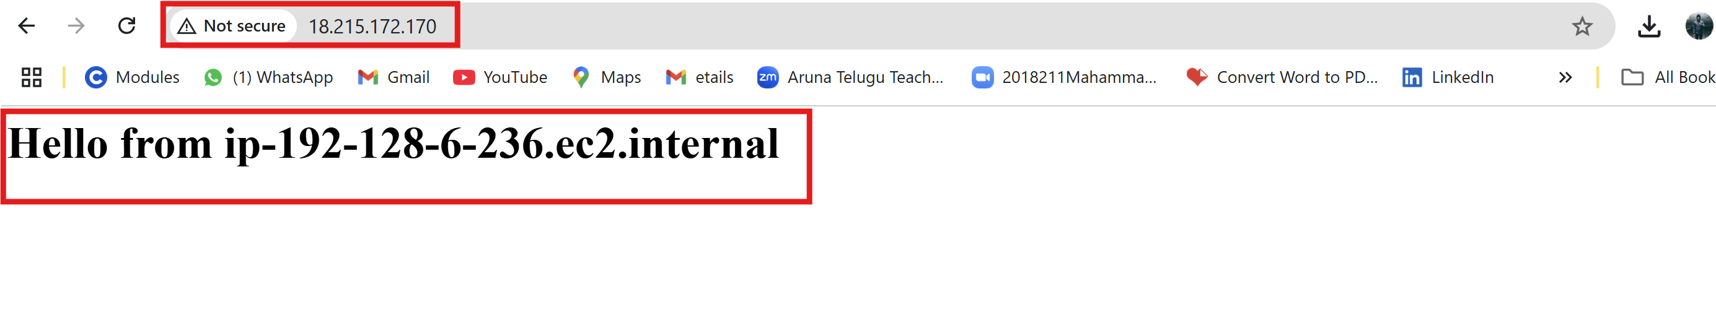

Using PvtIP:

* Then read the pem key from local machine and copy
* Then connect ec2 with public Ip and create one file “ Bastion.pem”

And paste the pem key value which previously copied and save

* Now check the internet connectivity for Private Ip by Ping pvtip
* Now connect Pvt Ip EC2 with bastion.pem

**ssh -i Bastion.pem** [**ec2-user@192.128.20.52**](mailto:ec2-user@192.128.20.52)

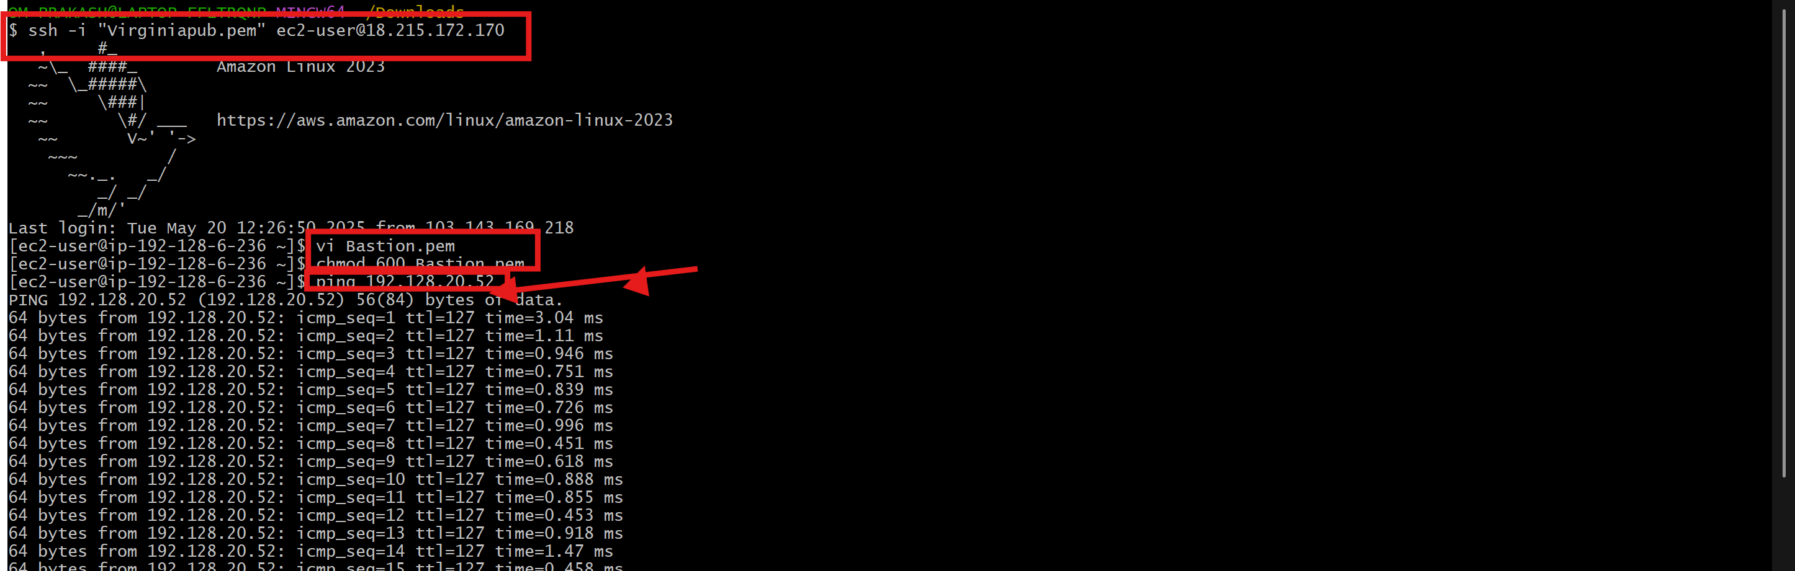

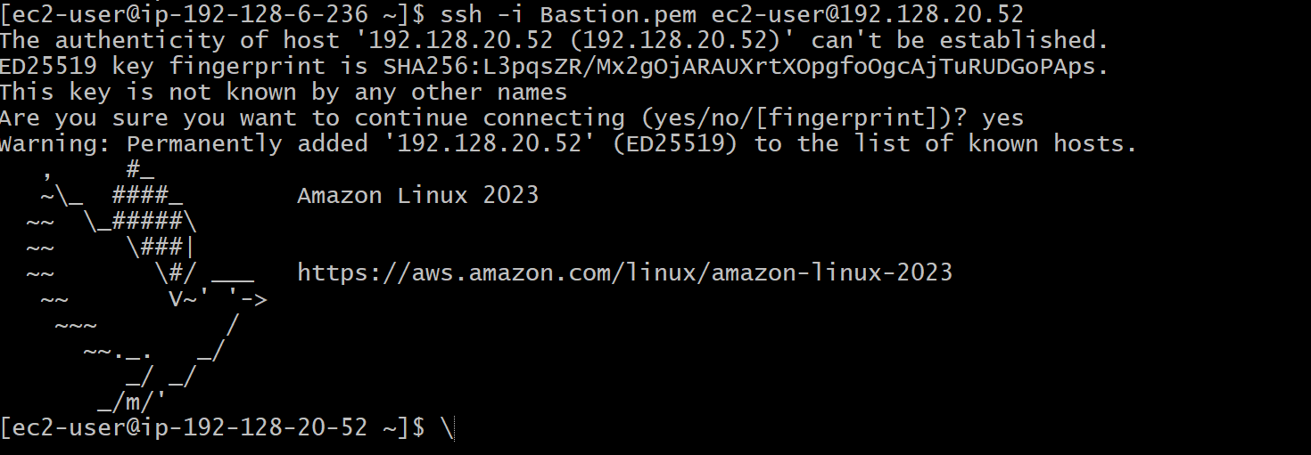

8) Create one application load balancer and attach the load balancer to both the ec2 instances.

Step 1: Create 2 instances with default vpc

Step2: connect with ssh then install apache and add the configuration file

Step 3: then check in the browser

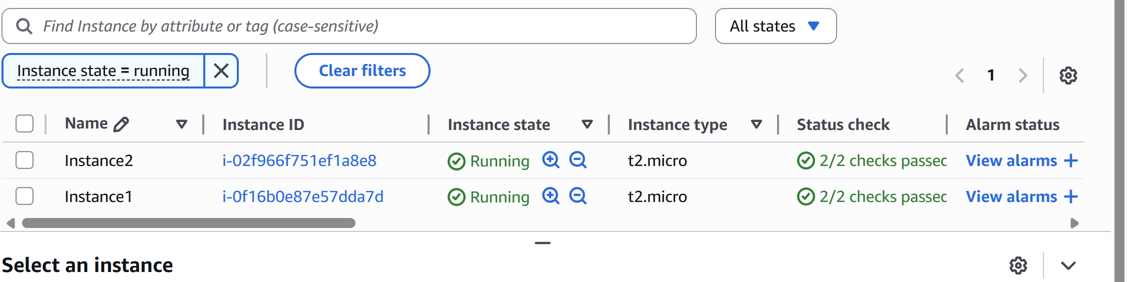

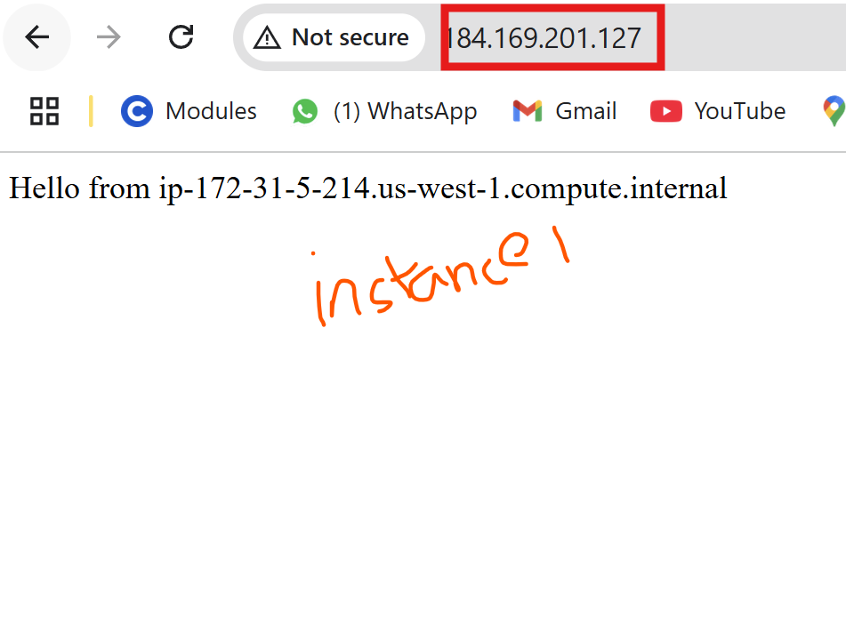

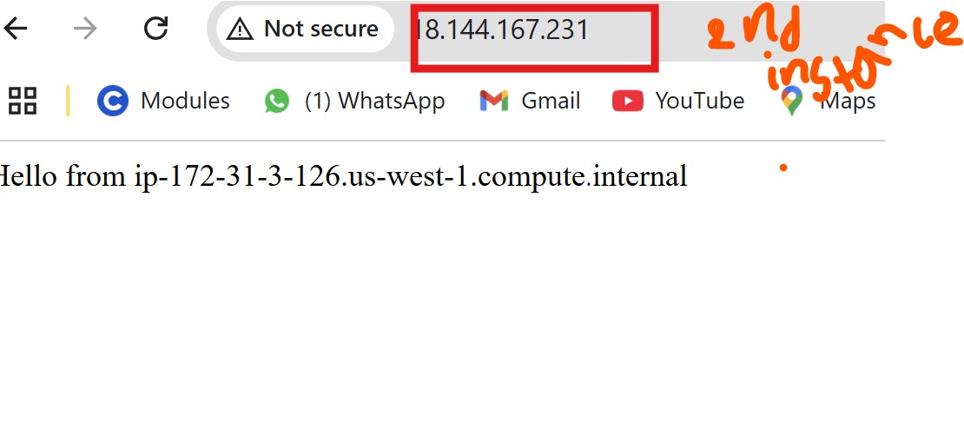

Step 4: Create Target Group

* Go to Ec2 -🡪under **load balancer** click **Target Groups**
* click creat target groups
* set

**Target type**: Instances

**Target group name**: my-target-group (or any name)

**Protocol**: HTTP

**Port**: 80

**VPC**: select your VPC

Leave health check settings as default or customize them.

* Click next
* Select the 2 Ec2 which we created before
* Click include as pending below
* Click create target group.

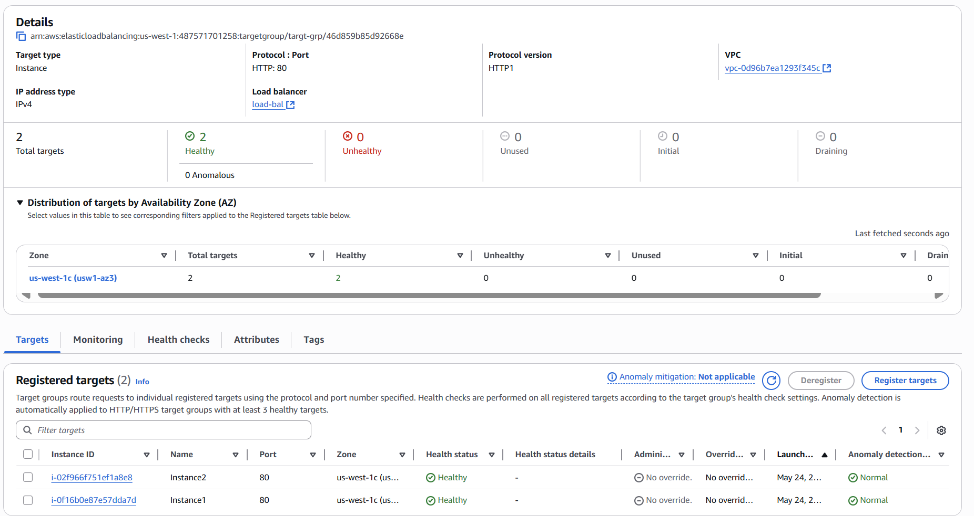

Step 5: **Create Application Load Balancer (ALB)**

* In the **EC2 Dashboard**, click on **Load Balancers**.
* Click **Create Load Balancer**.
* Select **Application Load Balancer**.
* Click **Create**.

**On the Configure Load Balancer page:**

* **Name**: my-alb
* **Scheme**: Internet-facing (or Internal for private use)
* **IP address type**: IPv4
* **Listeners**: Keep default HTTP on port 80.

**On the Availability Zones section:**

* Select your **VPC**.
* Choose **at least 2 subnets** in different Availability Zones.

Click **Next: Configure Security Settings** (skip this if using HTTP).

Step 6: Configure Security Group

* Choose an existing security group **OR** create a new one.
* Make sure the security group allows **inbound HTTP (port 80)** traffic.

Click **Next: Configure Routing**.

Step 7: **Configure Routing**

* + **Target group**: Choose **Existing target group**
  + Select the **target group** you created earlier (e.g., my-target-group)
  + Click **Next: Register Targets**.

Step 8: Register Targets

* + It will show that your targets are already registered (from Step 2).
  + Click **Next: Review**, then **Create**.

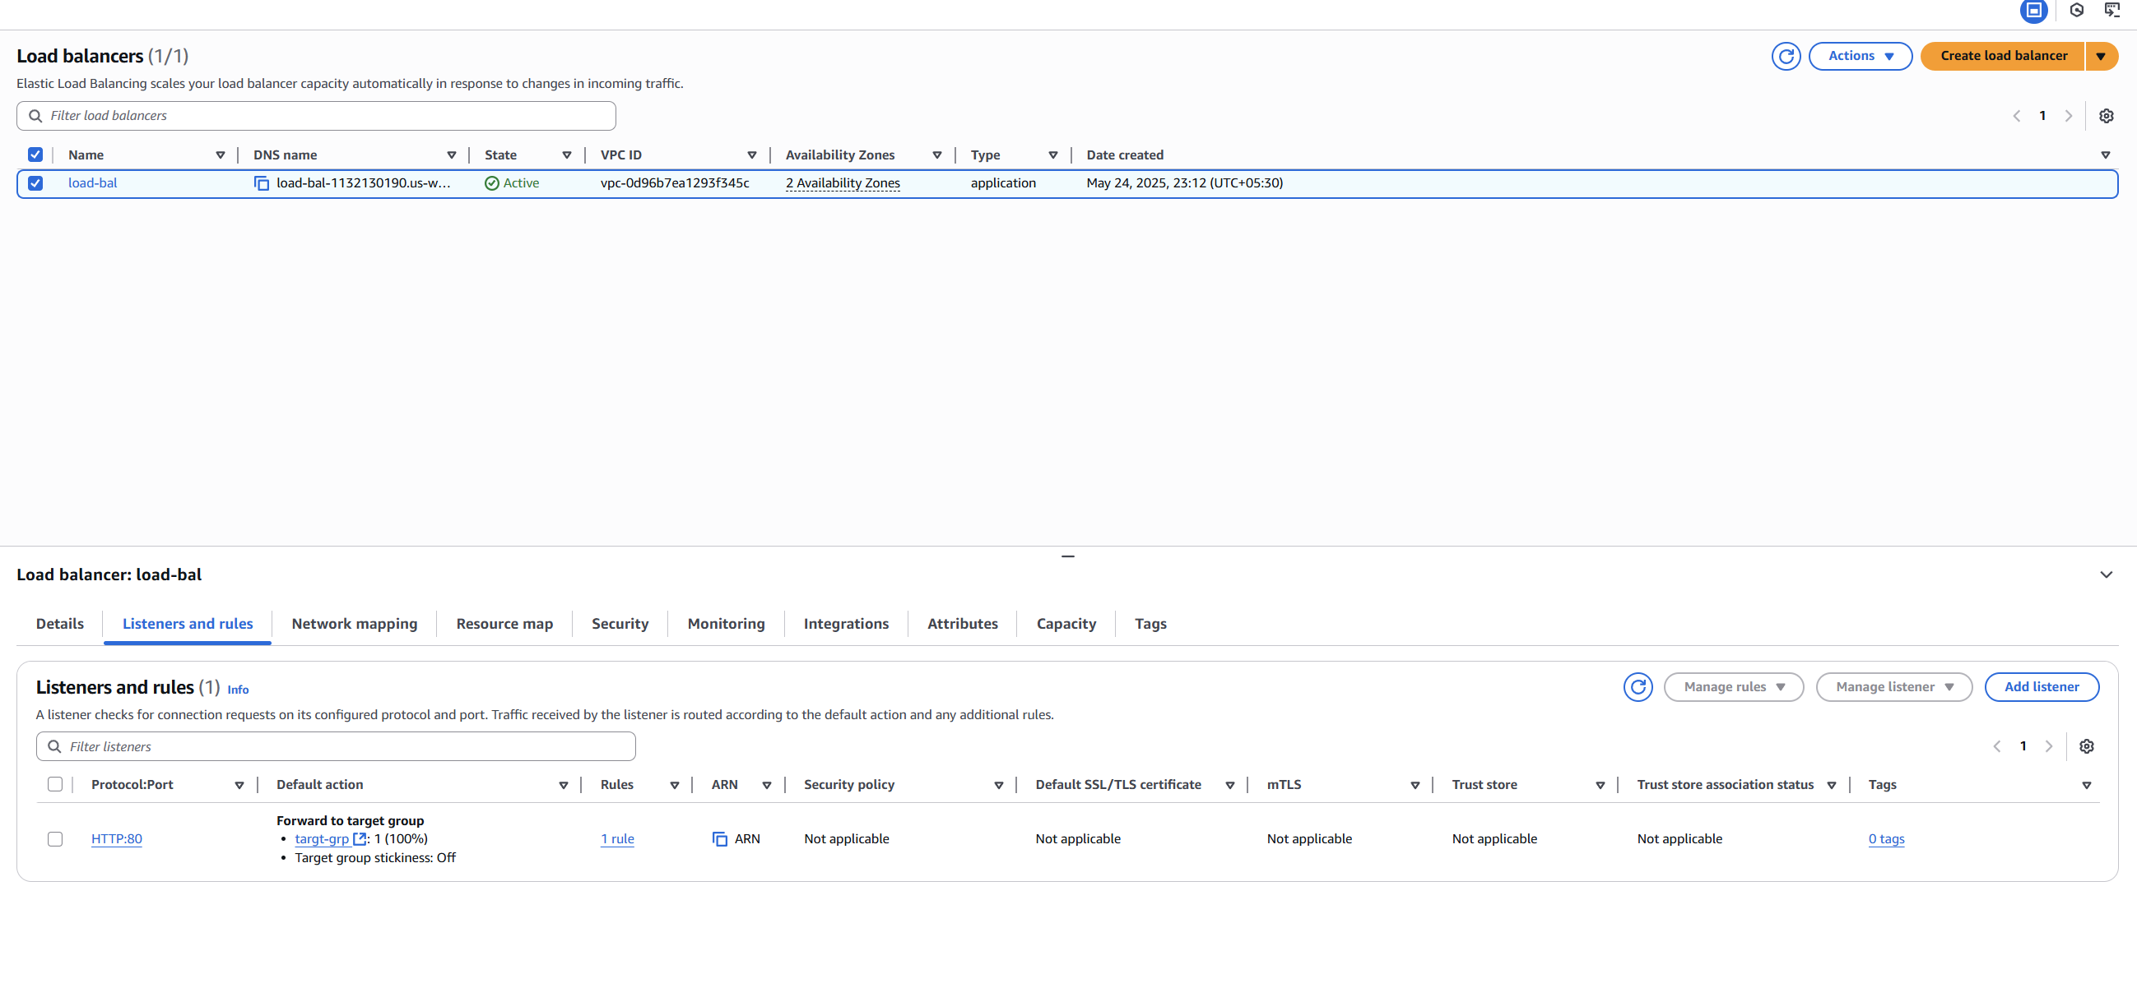

Step 9: **Test Your Load Balancer**

* + Go to **Load Balancers**, select your new ALB.
  + Copy the **DNS name** of the ALB.
  + Paste it into your browser — it should load your application (or default page) from one of the EC2 instances.

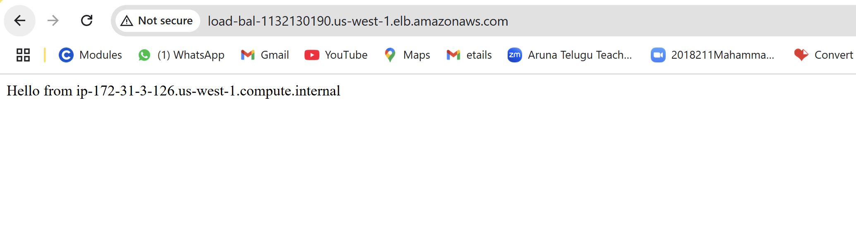

9) Store Application load balancer logs to s3.

Step 1: Create or Choose an S3 Bucket

* Go to **Amazon S3** in the AWS Console.
* Click **Create bucket** (or use an existing one).
* Name your bucket (e.g., my-alb-logs-bucket).
* Choose region (preferably same as your ALB).
* Click **Create bucket**.

Step 2: Add Bucket Policy to Allow ALB Logging

* Go to **S3** → open your bucket → **Permissions** tab.
* Scroll to **Bucket Policy** and click **Edit**.
* Add the following JSON (replace placeholders):

{

"Version": "2012-10-17",

"Statement": [

{

"Sid": "AWSALBLoggingPermissions",

"Effect": "Allow",

"Principal": {

"Service": "logdelivery.elasticloadbalancing.amazonaws.com"

},

"Action": "s3:PutObject",

"Resource": "arn:aws:s3::: **loadbalbucketlogs**/AWSLogs/487571701258/*"

}

]

}

Step 3: Enable Access Logs on ALB

* Go to **EC2** → **Load Balancers**.
* Select your **Application Load Balancer**.
* Go to the **Description** tab.
* Click **Edit attributes**.
* Scroll down to **Access logs**:
  + - ✅ Check **Enable access logs**
    - **S3 bucket name**: enter your bucket name

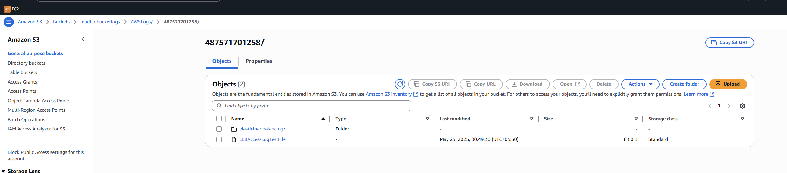

10) Store the vpc flow logs to cloudwtach group.

Step1: create log groups in cloud watch

* Go to 🡪cloudwatch🡪logs🡪log groups-🡪create log group

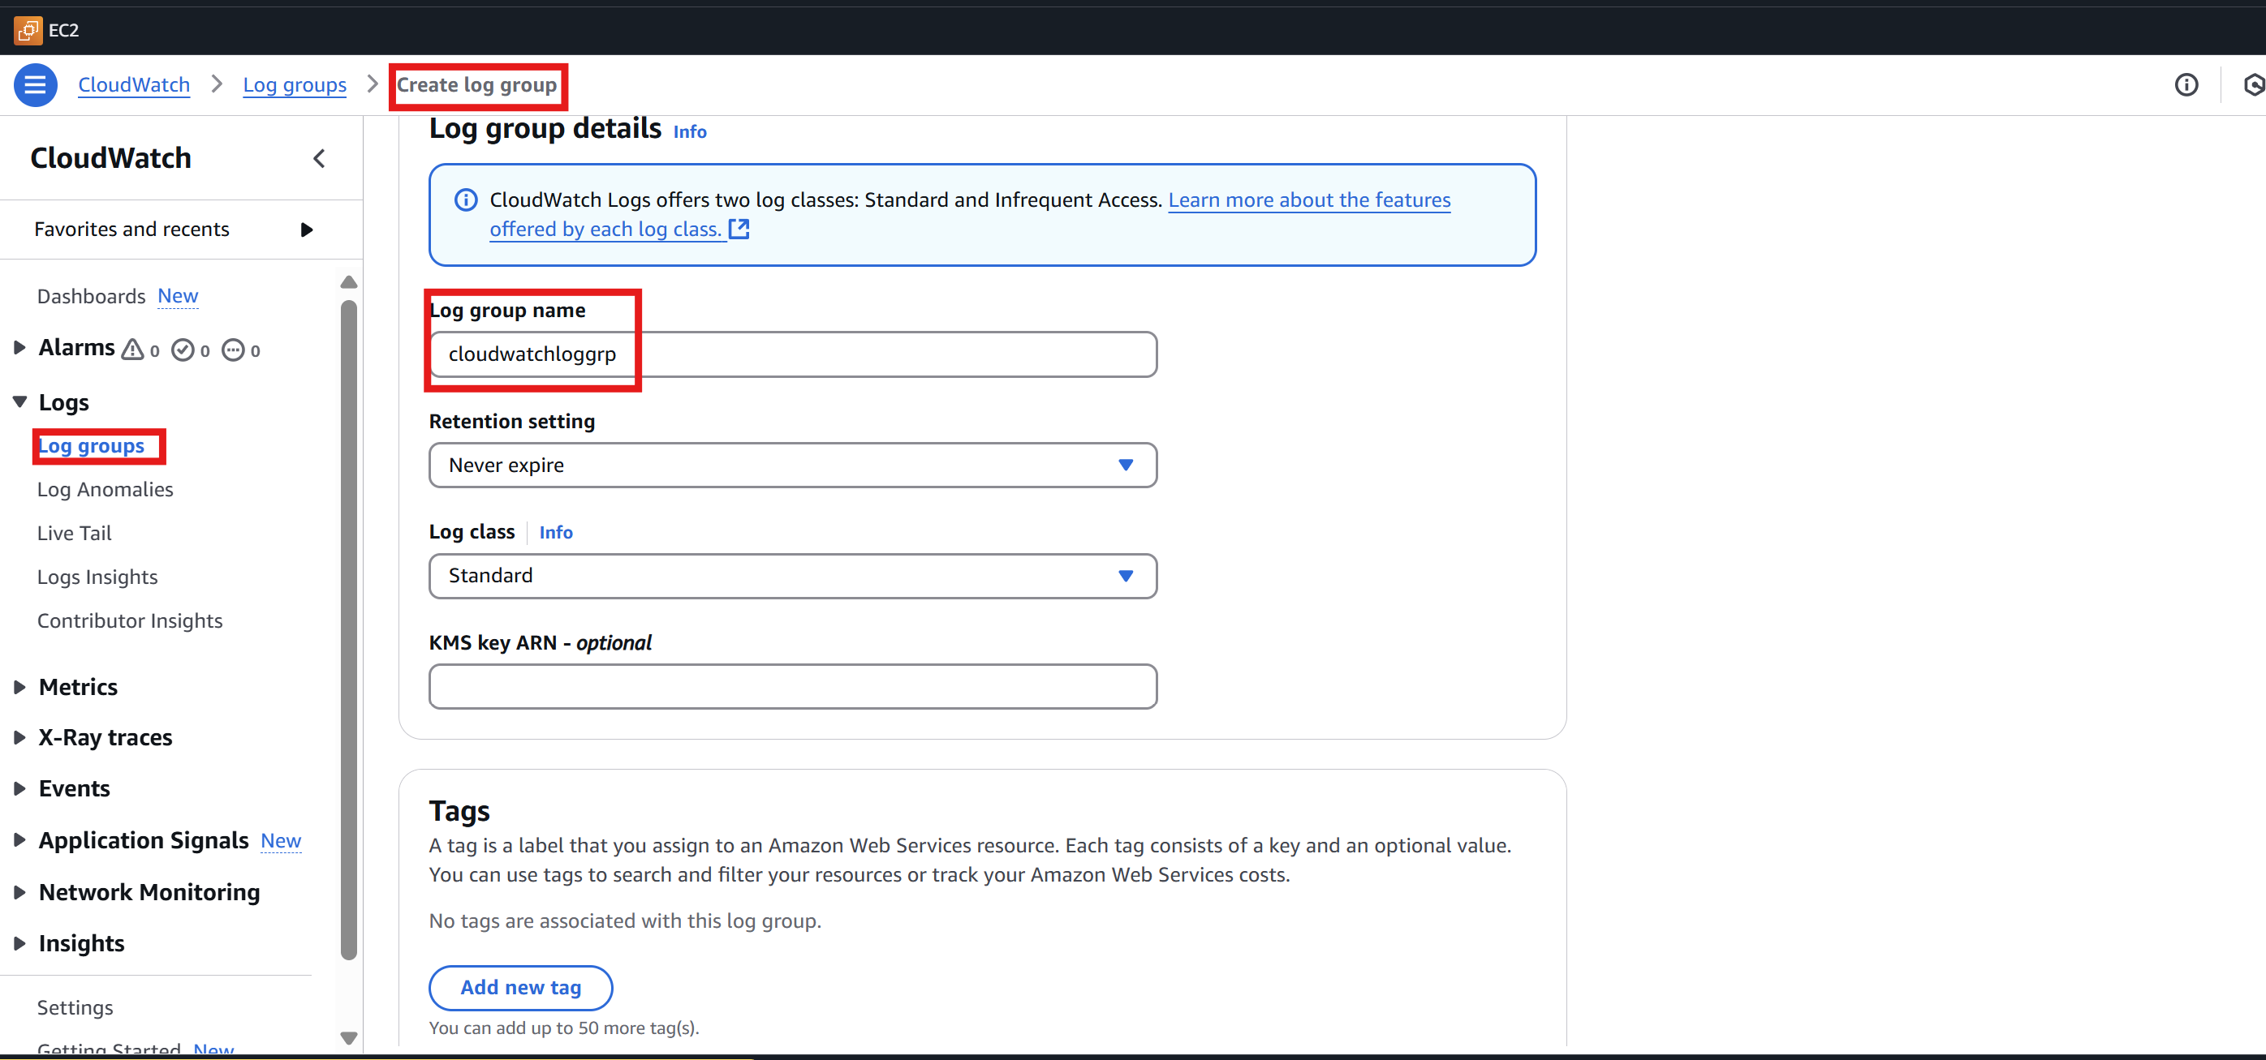

Step2: Attach flow log groups to VPC

* Go to VPC then action -🡪create flow log groups

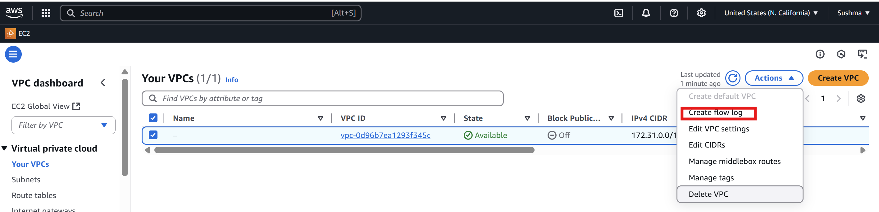

Step 3: Configure Flow Log Settings

**a. Filter:**

* Choose All, Reject, or Accept depending on the traffic you want to log.

**b. Destination:**

* Select **Send to CloudWatch Logs**.

**c. Log Group:**

* Either select an existing log group or click **Create log group** to make a new one.

**d. IAM Role:**

* If a suitable role exists, choose it.
* Otherwise, click **Set up permissions** to let AWS automatically create the correct role (recommended for simplicity).

Step 4: Click “Create flow log”

Once you click, your flow log will be set up, and VPC traffic will begin logging to CloudWatch Logs.

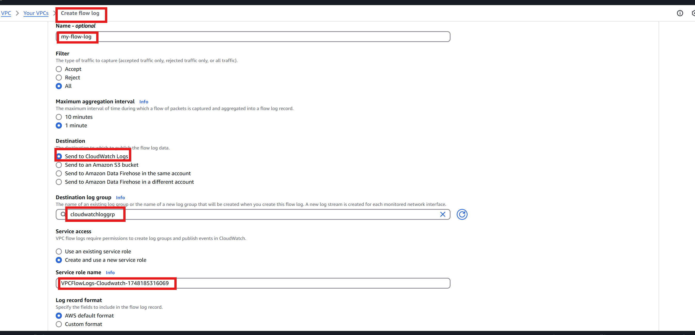

Step 5: **Verify the Flow Logs**

* Go to **CloudWatch** > **Logs**.
* Open the **Log Group** you chose.
* You’ll see **Log Streams** representing flow logs over time.

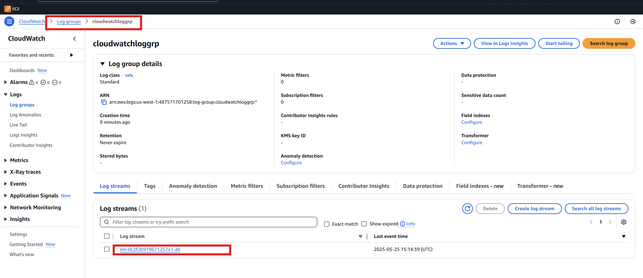

11) Create Monitoring Dashboards to monitor cpu utilization and to monitor apache service.

Step 1: Install and Configure CloudWatch Agent

**sudo yum install amazon-cloudwatch-agent -y**

step 2: Attach a IAM role to the EC2 instance with below policy

{

"Version": "2012-10-17",

"Statement": [

{

"Effect": "Allow",

"Action": "cloudwatch:PutMetricData",

"Resource": "*"

}

]

}

Step 2: Create a Custom Script to Check Apache

**sudo nano /opt/aws/apache-status.sh**

SERVICE="httpd"

if systemctl is-active --quiet $SERVICE; then

STATUS=1

else

STATUS=0

fi

aws cloudwatch put-metric-data \

--metric-name ApacheStatus \

--namespace "Custom/Apache" \

--value $STATUS

* sudo chmod +x /opt/aws/apache-status.sh

Step 3: Create CloudWatch Agent Configuration

Create this file: /opt/aws/amazon-cloudwatch-agent/bin/config.json

{

"metrics": {

"metrics_collected": {

"exec": [

{

"command": "/opt/aws/apache-status.sh",

"measurement": [

"ApacheStatus"

],

"metrics_collection_interval": 60

}

]

},

"namespace": "Custom/Apache"

}

}

Step 4: Start the CloudWatch Agent

sudo /opt/aws/amazon-cloudwatch-agent/bin/amazon-cloudwatch-agent-ctl \

-a fetch-config \

-m ec2 \

-c file:/opt/aws/amazon-cloudwatch-agent/bin/config.json \

-s

Step 5:

aws cloudwatch put-metric-data \

--metric-name ApacheStatus \

--namespace "Custom/Apache" \

--value 1

Step 6: Add Widget to Dashboard

Now go to:

* **CloudWatch > Dashboards > YourDashboard > Add Widget**
* Choose Custom/Apache > ApacheStatus
* Visualize as Number or Line chart

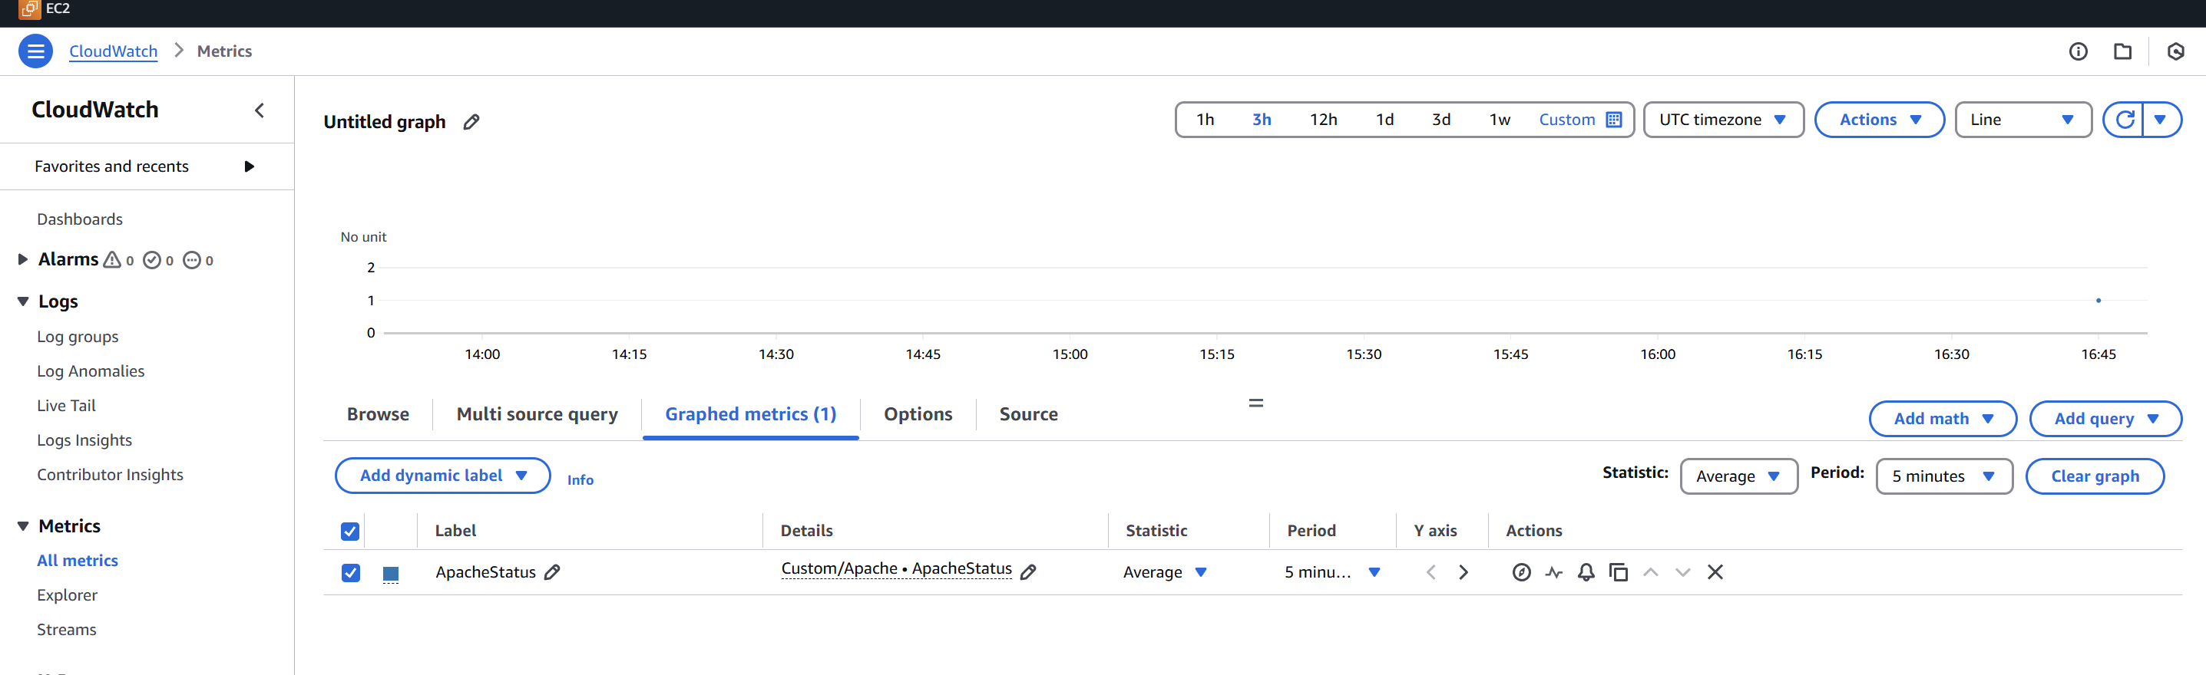

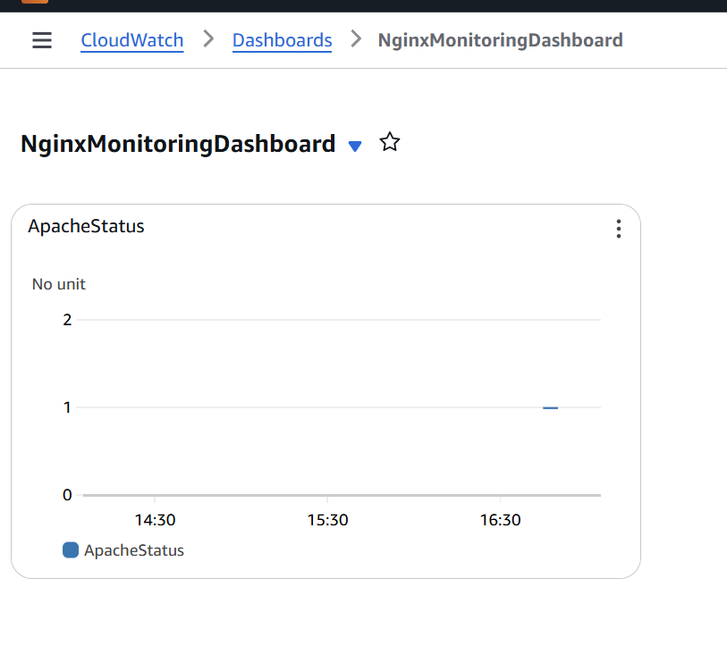

12) CPU utilizationis more than 70% then it should triggere Autoscaling and launch new instance.

Step 1: Create a Launch Template

* Go to **EC2 Console**.
* In the left pane, click **Launch Templates**.
* Click **Create launch template**.
* Enter:
  + - **Template name**: my-launch-template
    - **Template version description**: optional
    - **AMI**: Select an Amazon Linux or Ubuntu AMI.
    - **Instance type**: e.g., t2.micro
    - **Key pair**: Select an existing key.
    - **Network settings**:

• Choose your **VPC** and **Subnet**.

• Enable **Auto-assign public IP** if needed.

• Select a **Security Group** that allows SSH/HTTP.

* Click **Create launch template**.

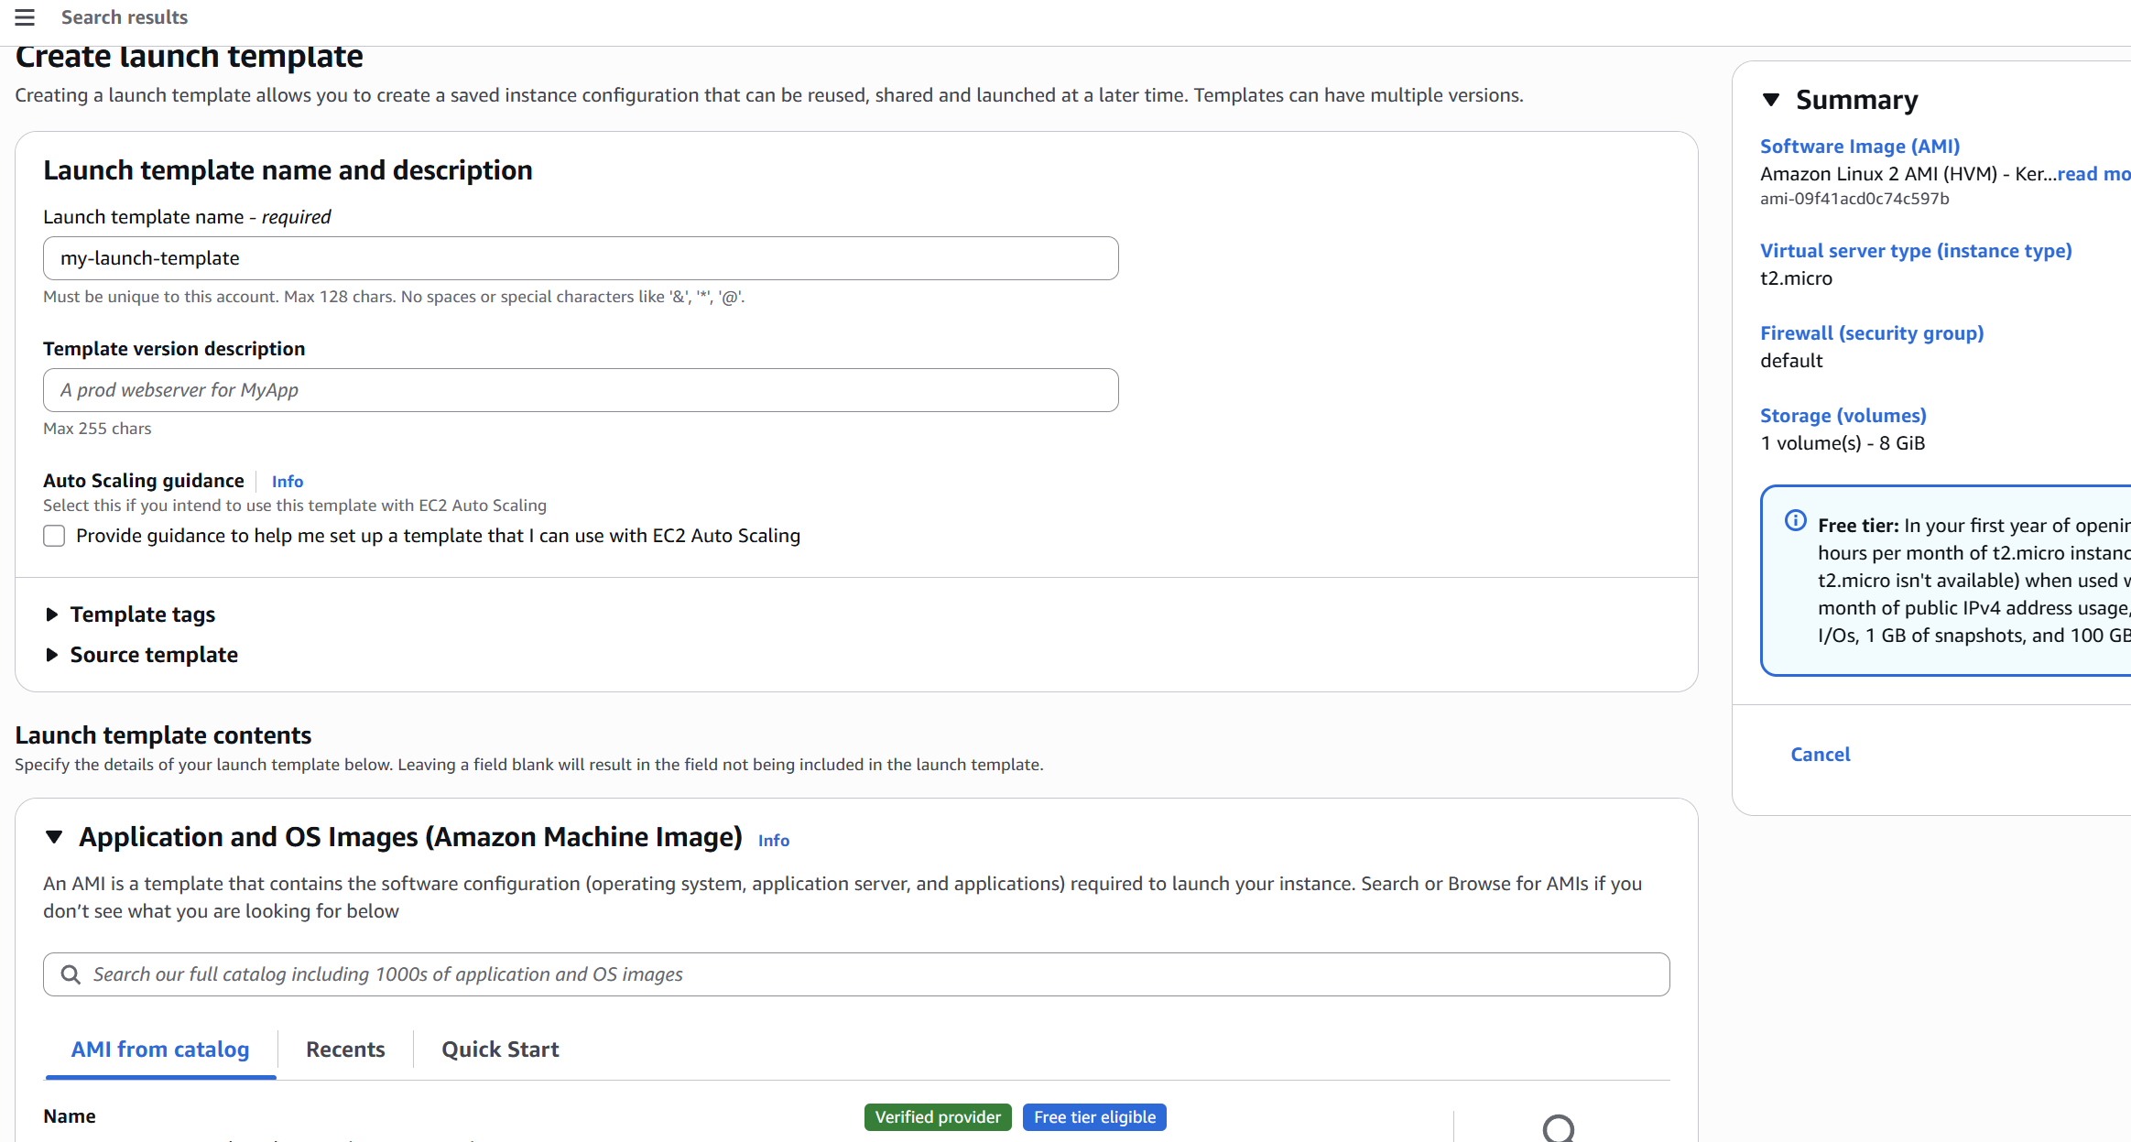

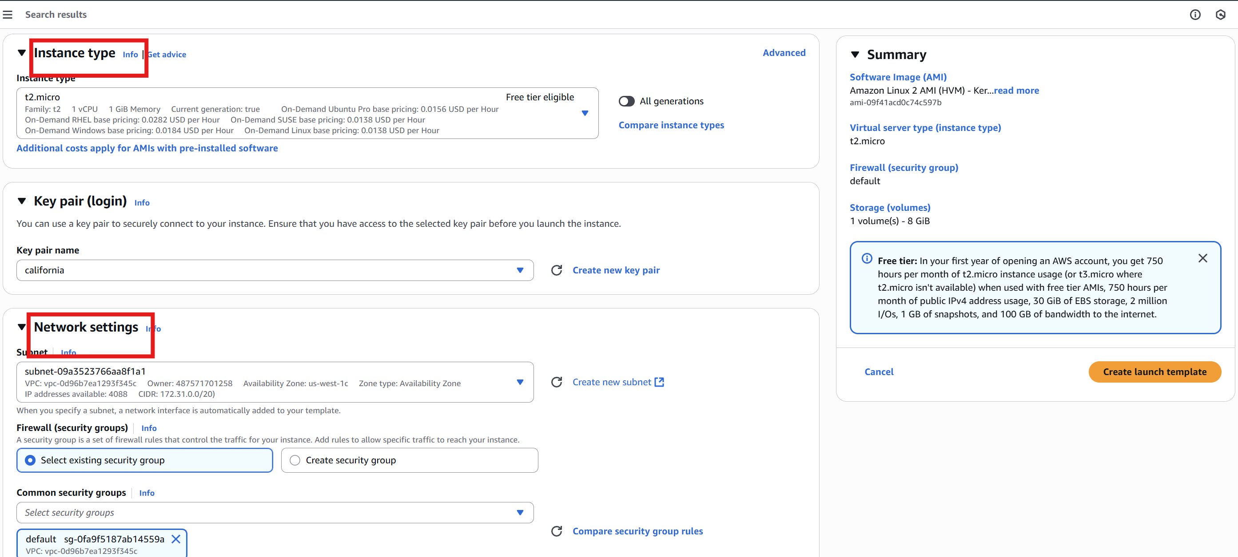

Step 2: Create Auto Scaling Group

* Go to **EC2 Console → Auto Scaling Groups**.
* Click **Create Auto Scaling group**.
* Name it e.g., my-asg.
* **Choose launch template**:
  + - Select the one created in Step 1.
* **VPC and subnets**:
  + - Choose the VPC and at least 2 subnets in different AZs.
* **Instance purchasing options**: leave default.
* **Instance protection & health check**:
  + - Use EC2 health check.
* **Group size**:
  + - Desired: 1
    - Min: 1
    - Max: 3
* Skip **Scaling policies** for now — you’ll add them separately.
* Review and click **Create Auto Scaling group**.

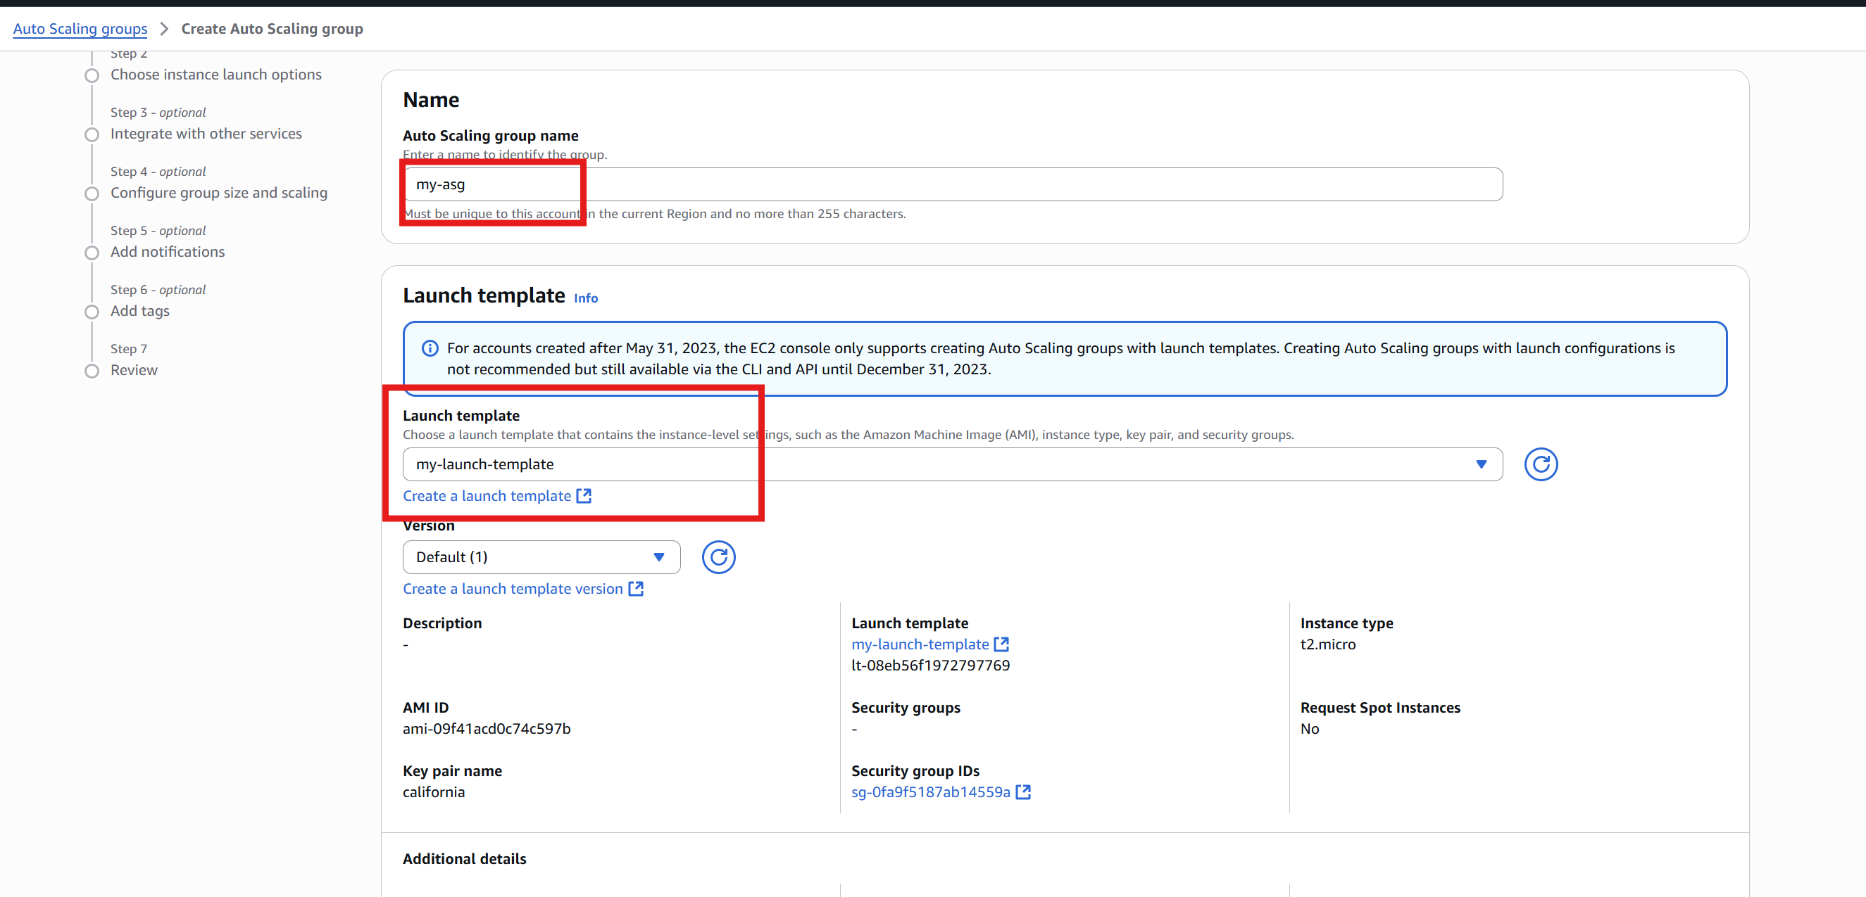

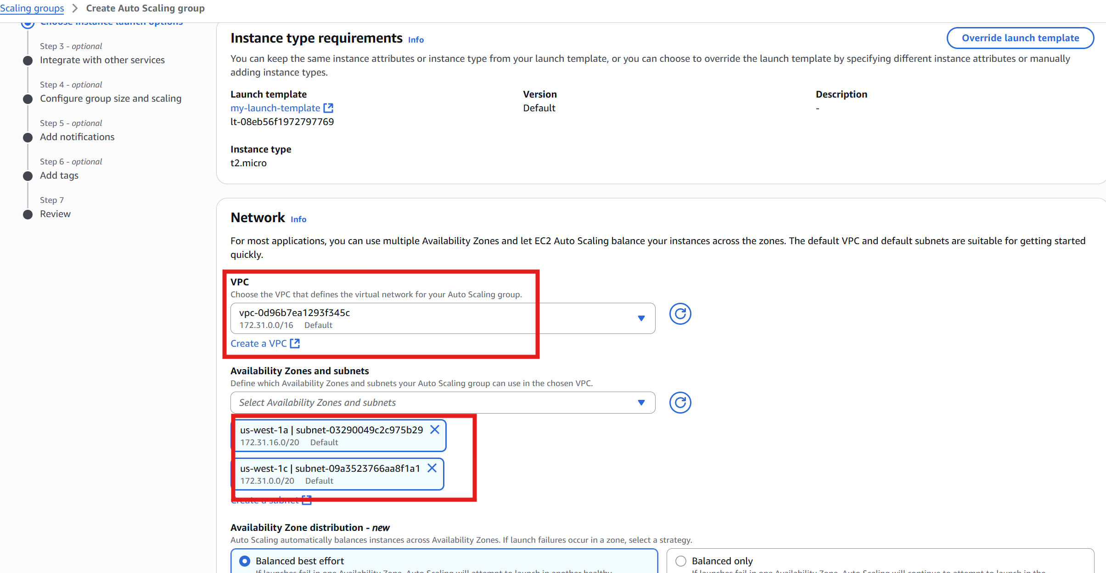

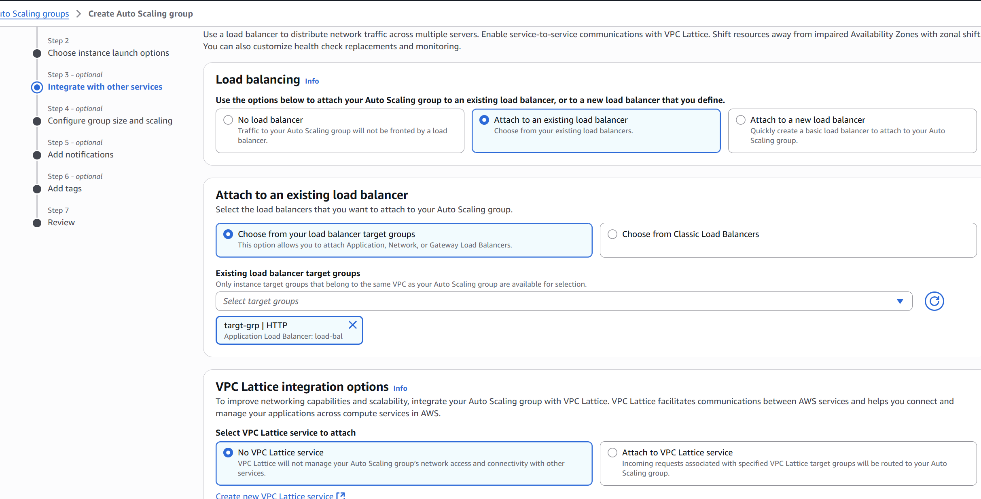

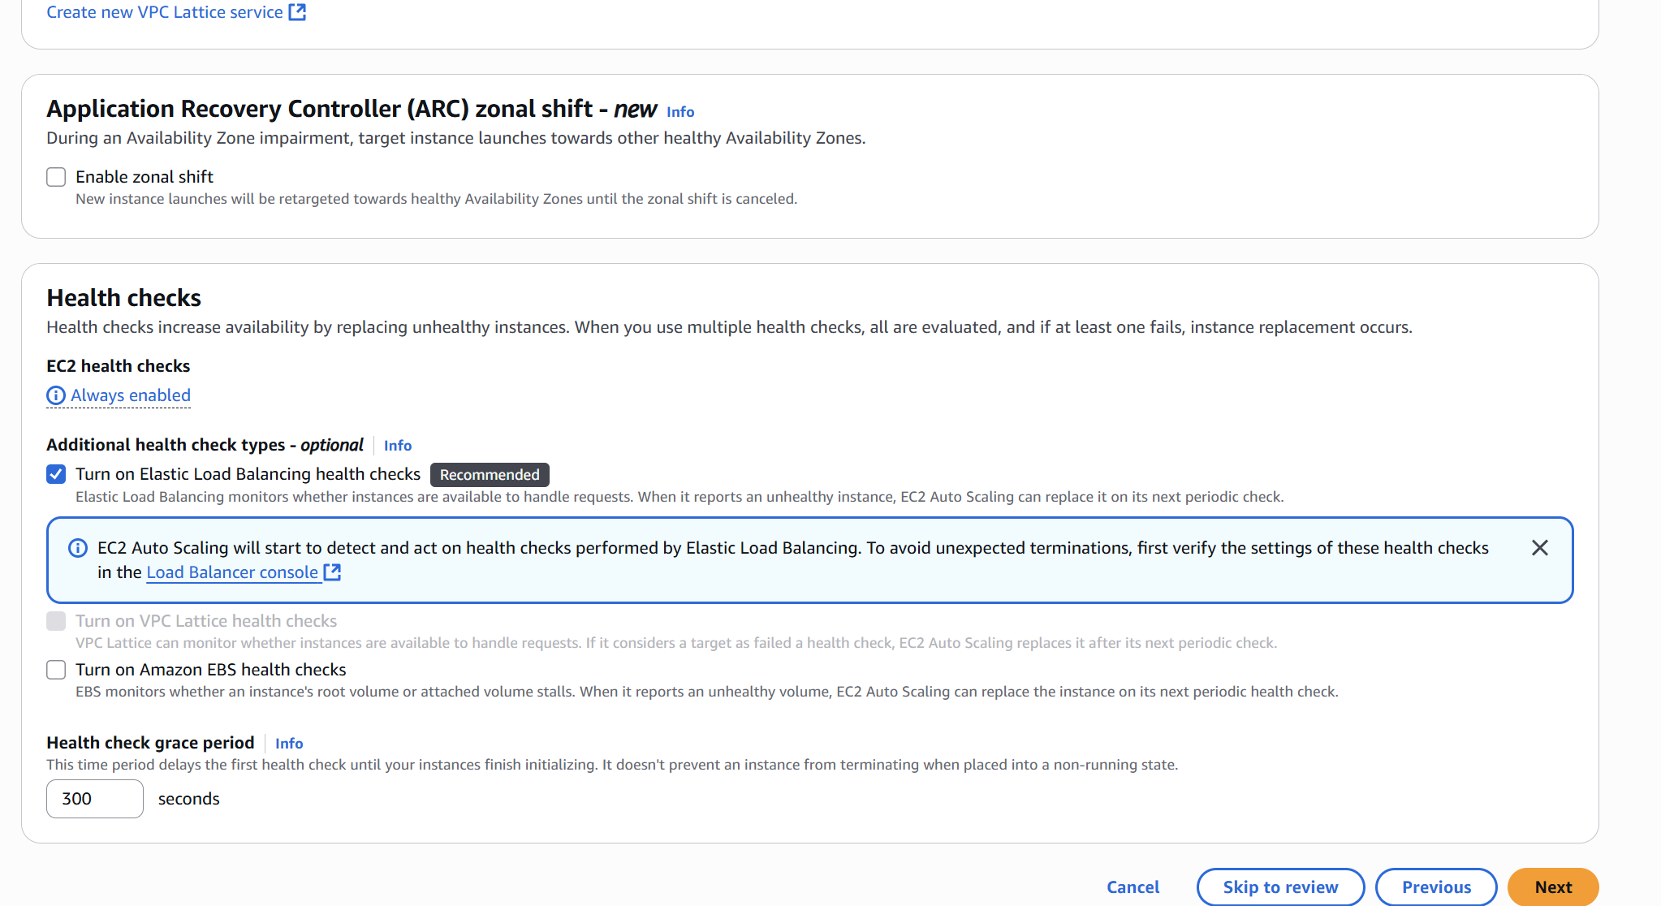

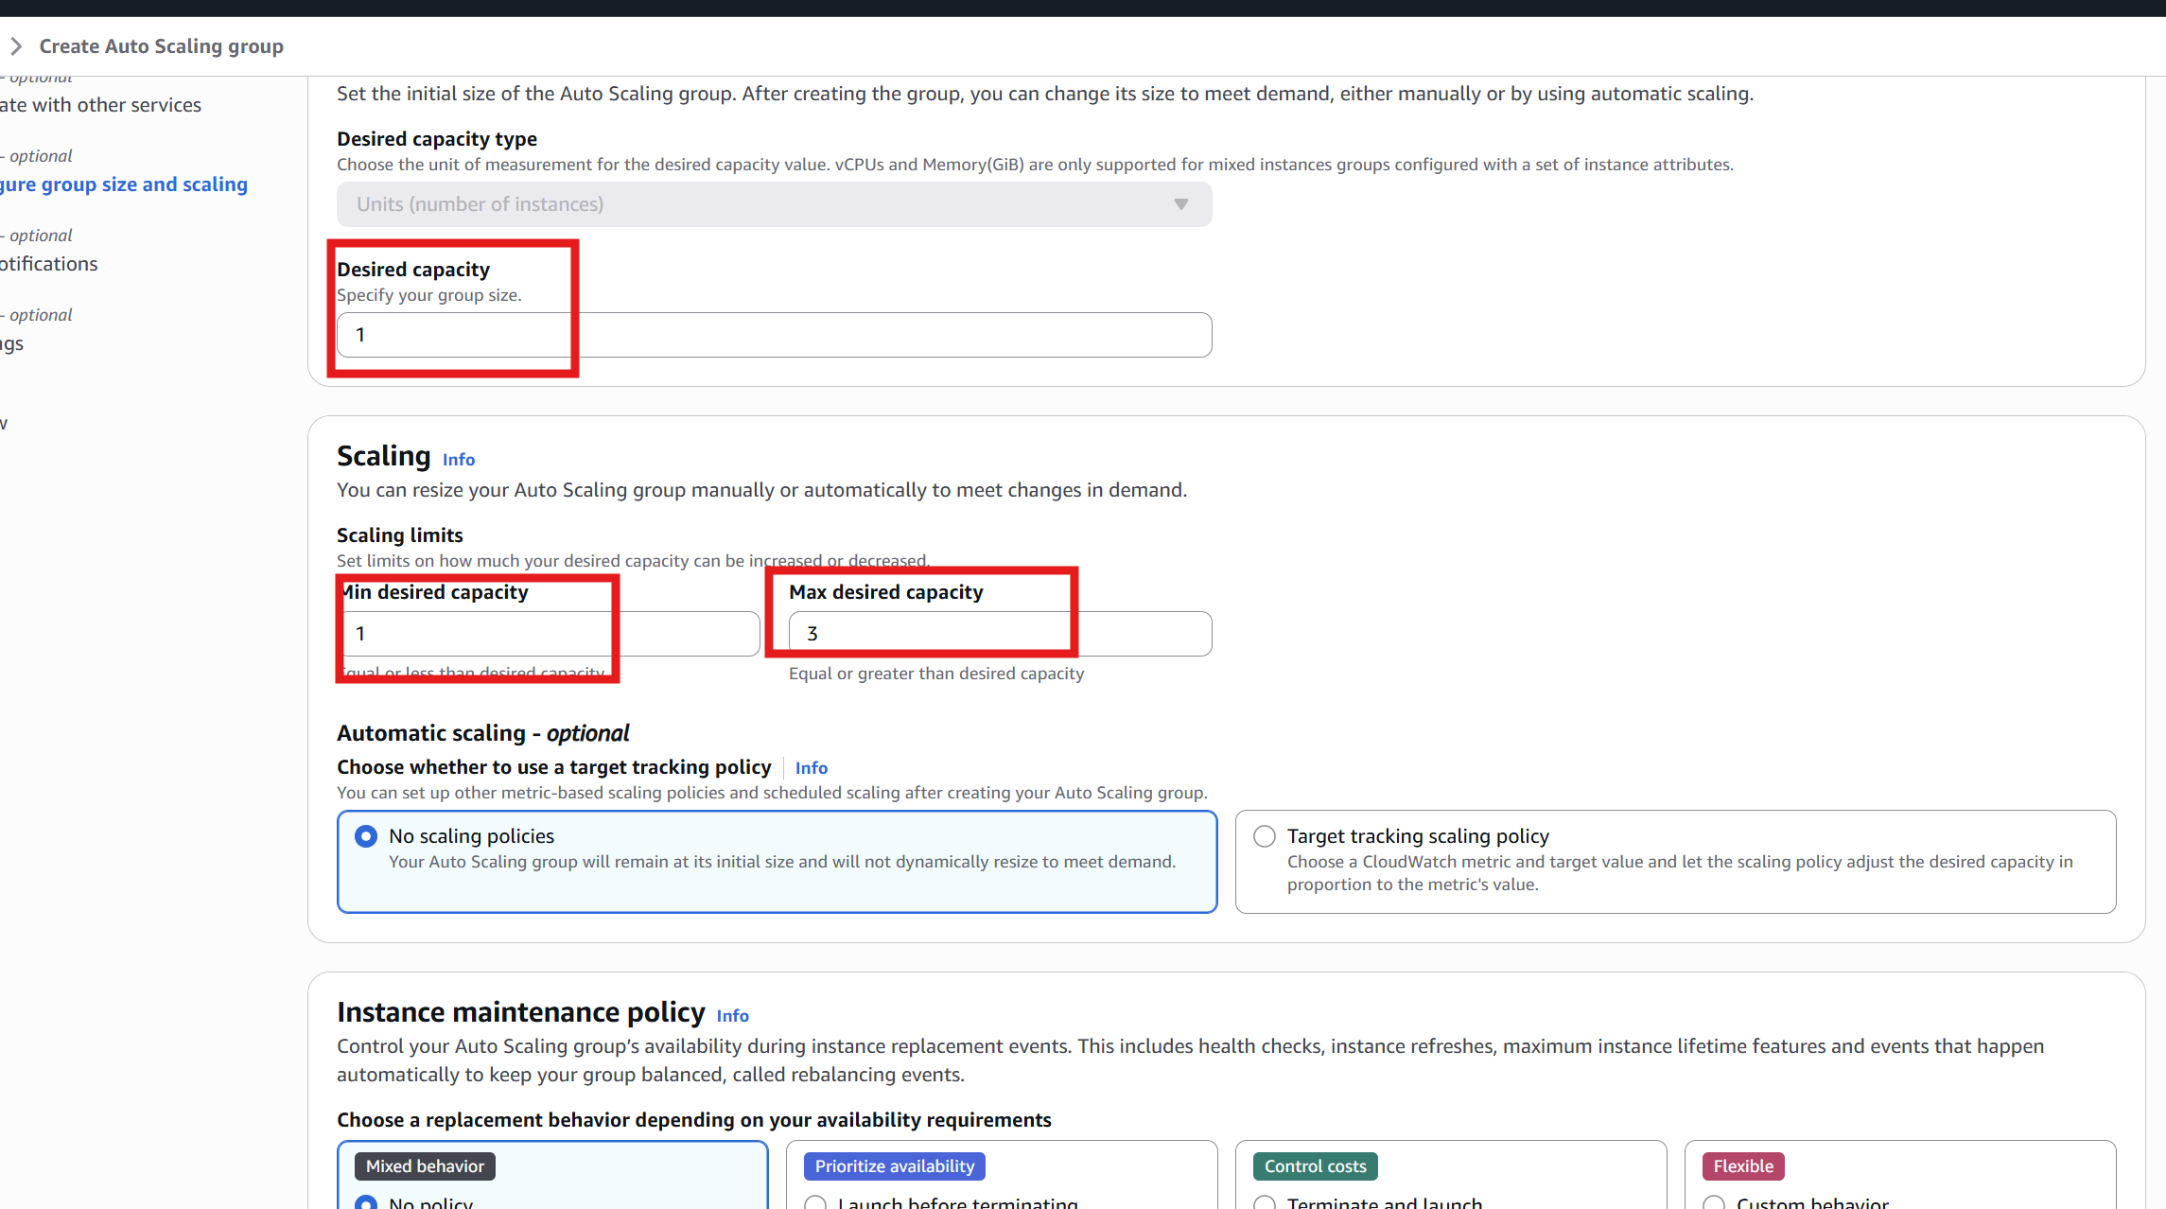

Step 3: Create CloudWatch Alarm for CPU Utilization

* Go to **CloudWatch → Alarms → Create Alarm**.
* Click **Select metric** → **EC2 → Per-Instance Metrics**.
* Find and select **CPUUtilization** for your instance or ASG.
* Click **Select metric**.
* Set conditions:
  + - **Threshold type**: Static
    - **Whenever CPUUtilization is >= 70 for 2 consecutive periods of 5 minutes**
* Click **Next**.
* **Notification** (optional): Select or create an SNS topic to get alerts.
* Click **Next**, give the alarm a name like Alarm, then click **Create alarm**.

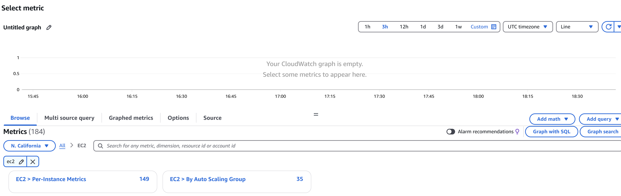

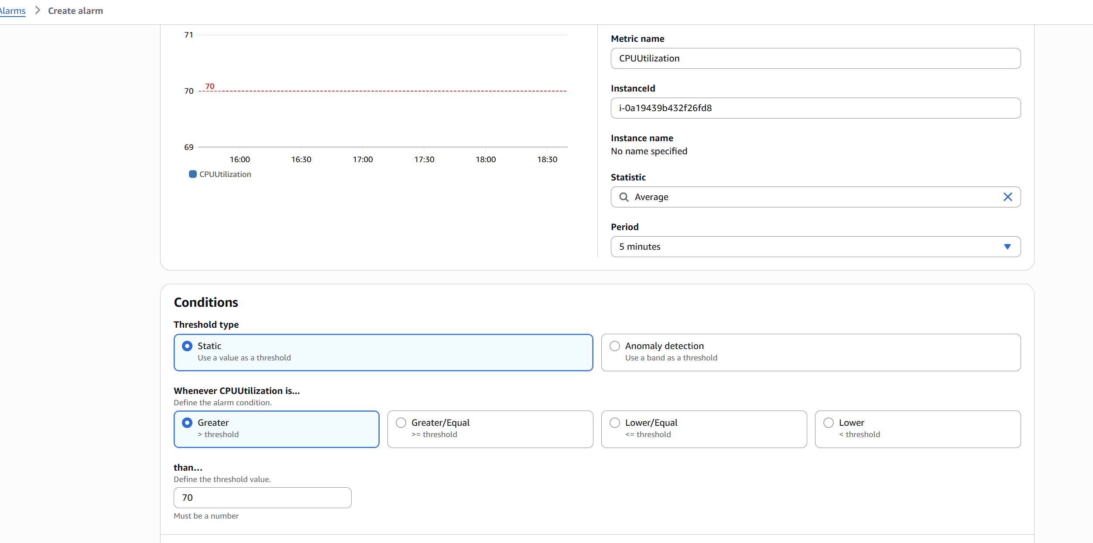

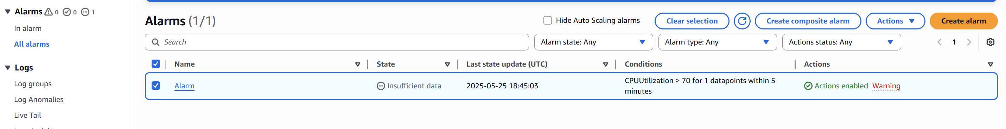

Step 4: Create Scaling Policy and Attach to Alarm

* Go back to **EC2 → Auto Scaling Groups**.
* Select your ASG → Go to the **Automatic Scaling** tab.
* Click **Add policy**.
* Choose **Target tracking** OR **Step/Scale policy**:
  + For step scaling:
    - Name: ScaleOutPolicy
    - Policy type: Step scaling
    - Metric: CPUUtilization
    - Condition: If >= 70%, add 1 instance.
* After creating the policy, click on **Add Alarm**.
* Select the previously created alarm HighCPUAlarm and attach it to this policy.

Result:

* The ASG starts with 1 instance.
* If CPU > 70%, CloudWatch alarm triggers.
* Alarm notifies the ASG via the scaling policy.
* ASG adds a new instance (up to 3).

